Dual Language and Immersion Family Education:
Supporting Students in Secondary Programs
Session 1

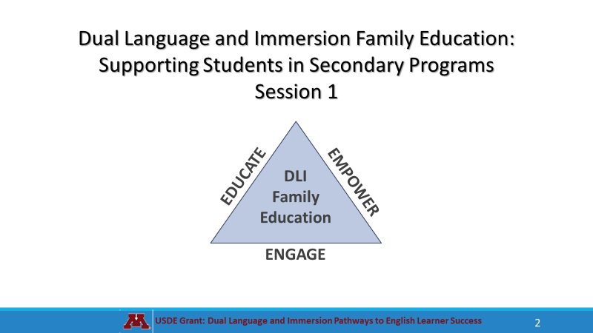  The Dual Language and Immersion Family Education program is supported by a United States Department of Education grant from the Office of English Language Acquisition.  We are going to be giving these sessions bilingually rather than separating you into different language groups. Your children are together for instruction and that integration is key to program success. Keep in mind, however, that although we will be doing these sessions bilingually, your children are taught in one language or the other – the teachers don’t translate or use both languages during their instruction. | 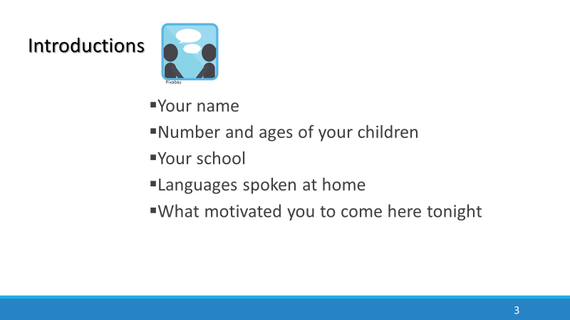
 | 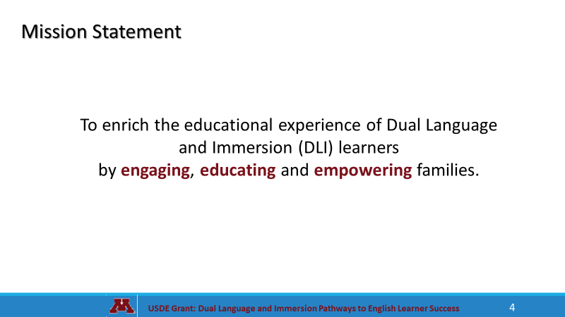
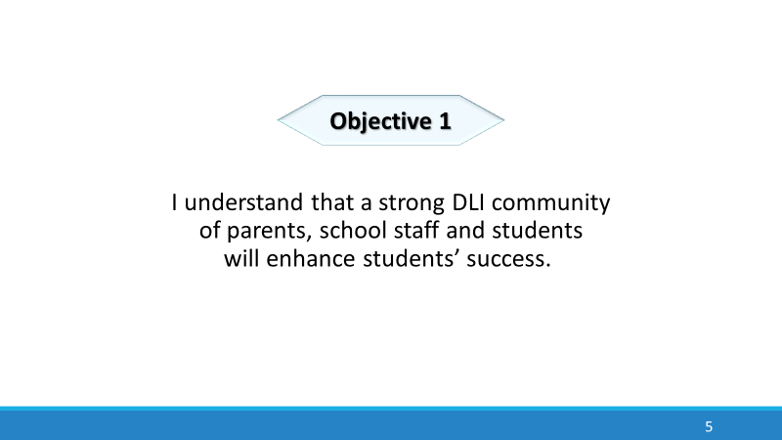 | 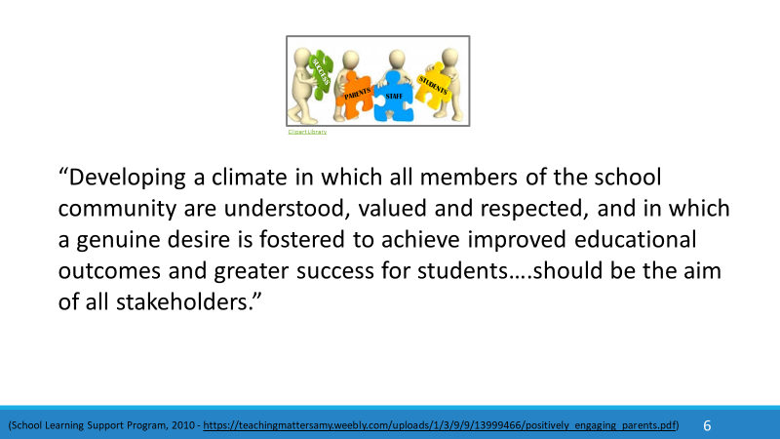
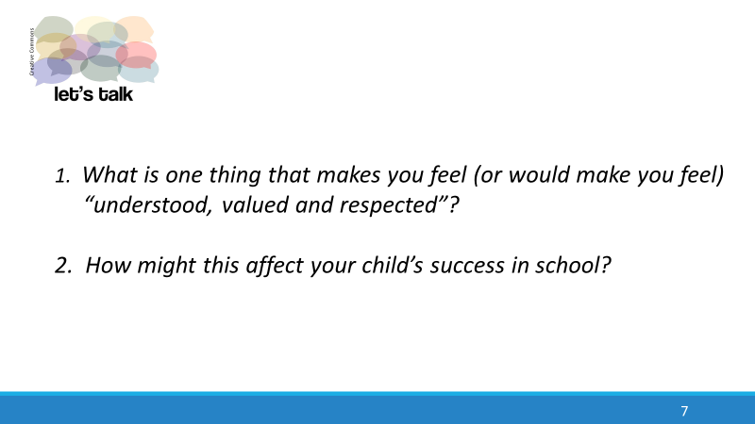 | 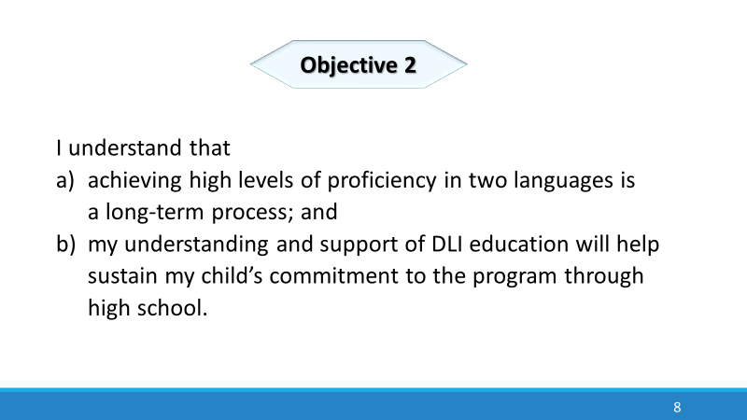
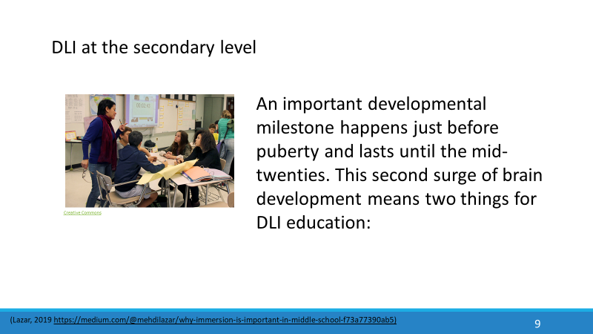 | 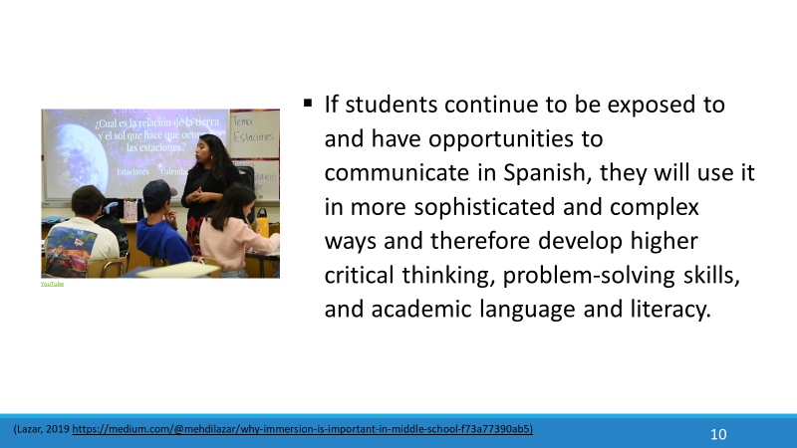
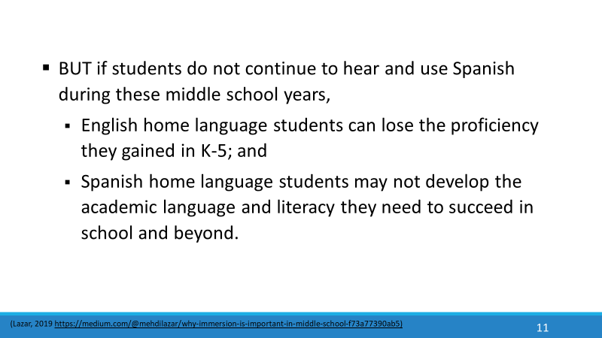 | 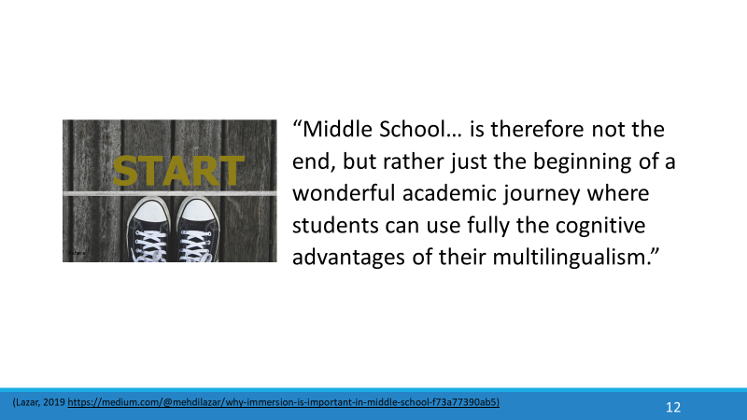  Your child may not see this. It’s up to you to keep your child on course.
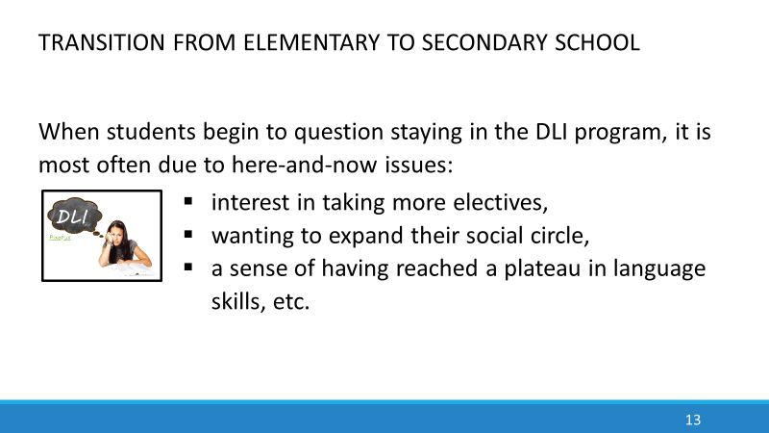 | 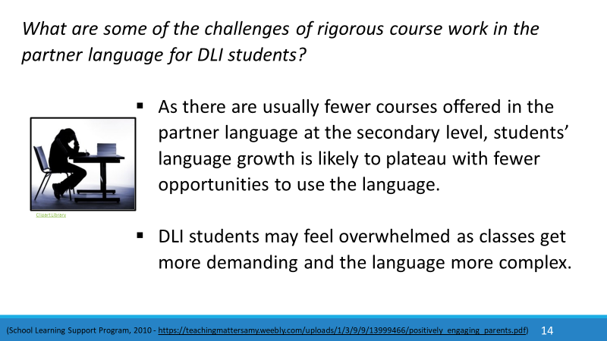
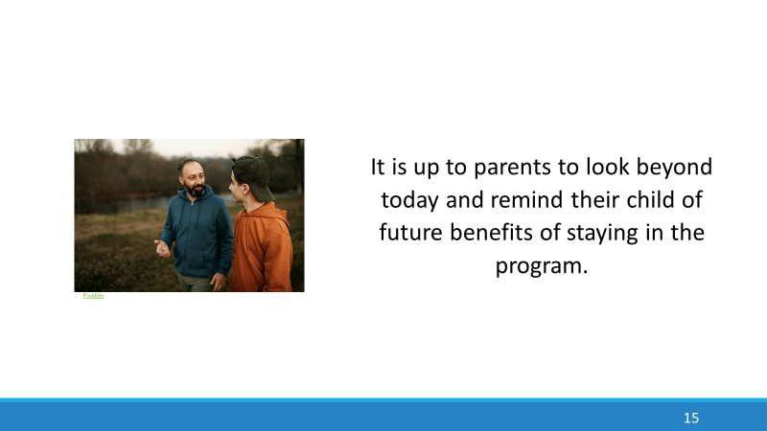 | 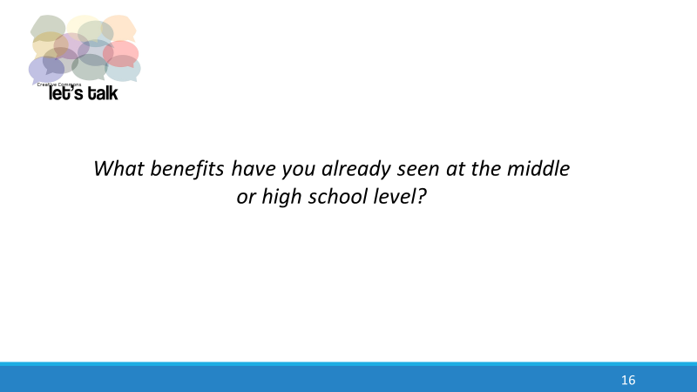
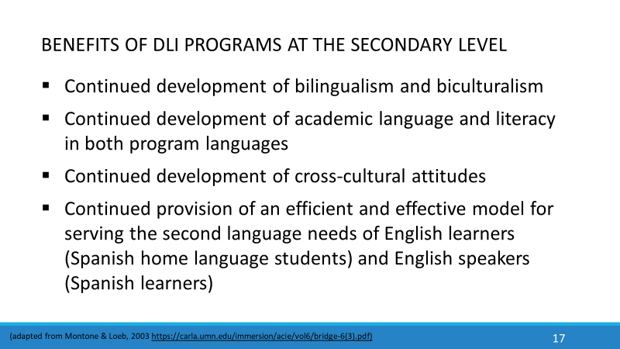 | 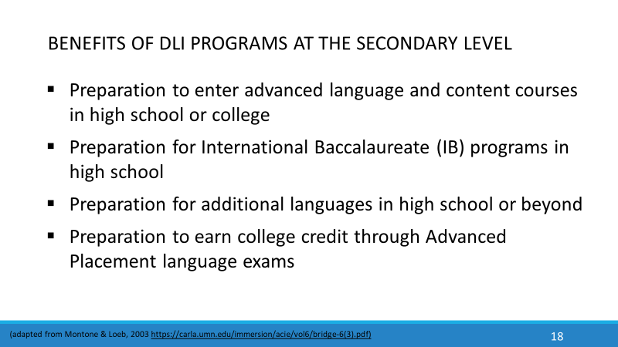
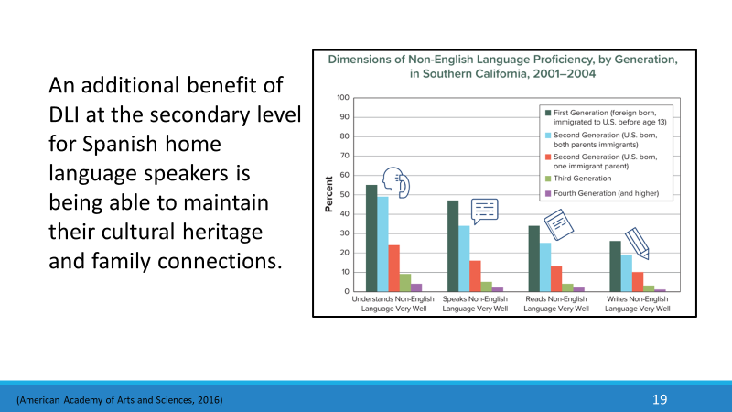 | For immigrant families, the ability to understand, speak, read, and write the home language disappears very quickly. A study in Southern California found that only 45% of first-generation adults who immigrated to the United States before the age of 13 could still speak the language of their parents well. Only 35% of second-generation immigrants could speak their home language. And only 5% of third-generation immigrants could speak the language of their grandparents. Without making a conscious effort to maintain it, families can lose their home language in 3 to 4 generations, showing just how powerful English is in the U.S.
 | 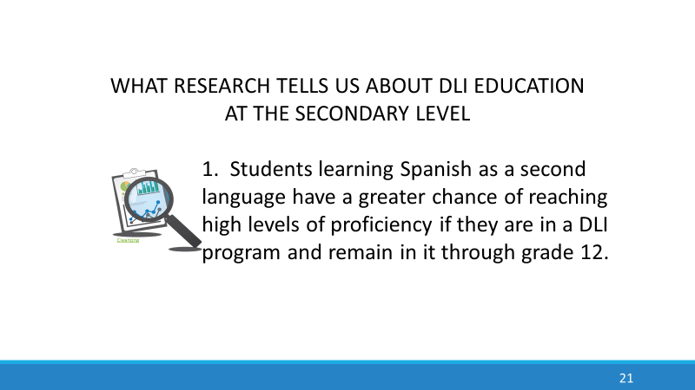
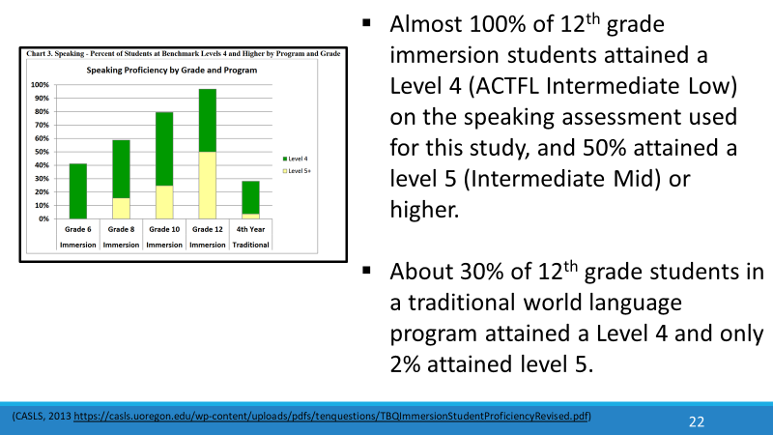 | In a 2011 study, sponsored by the U.S. Department of Education, researchers used a database of 1,477 students enrolled in Spanish, French, Japanese, or Chinese immersion language programs in 14 states across the U.S. By grade 12, DLI Students outperformed their non-DLI peers in reading, writing and, especially, speaking the second language.  ACTFL stands for American Council on the Teaching of Foreign Languages. The ACTFL Proficiency Guidelines are a description of what individuals can do with language in terms of speaking, writing, listening, and reading in real-world situations in a spontaneous and non-rehearsed context.
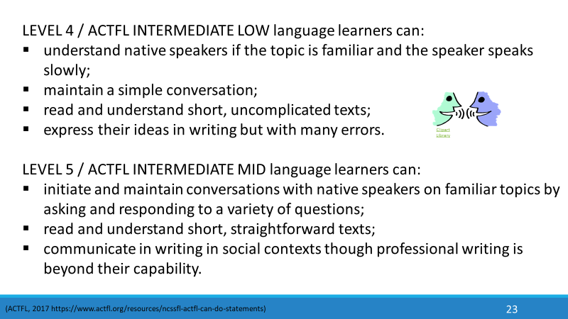  Here are some general descriptions of speaking, reading and writing levels of Intermediate Low and Intermediate Mid language learners. | 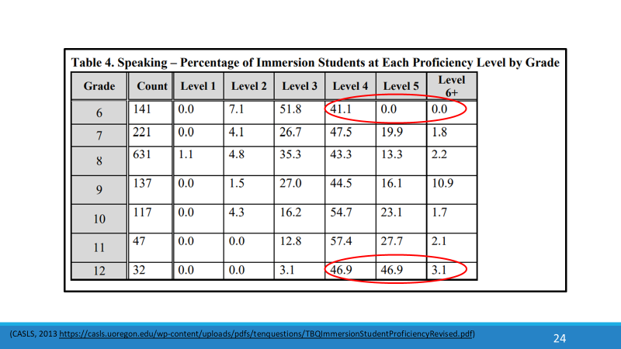  This graph from the same study shows speaking scores of immersion students from grade 6 to grade 12. Only about 41% of sixth graders were at a combined score of levels 4-6. It took until grade 12 to reach the combined score of 96.9% for levels 4 - 6. This graph also shows a dramatic drop-off in level 6+ between 9th and 10th grade. This is often the point between middle and high school, where fewer courses are offered in the immersion language.
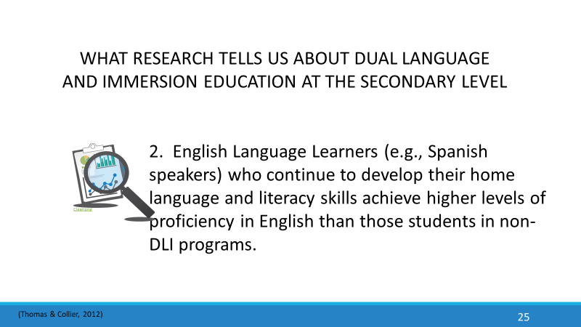 | 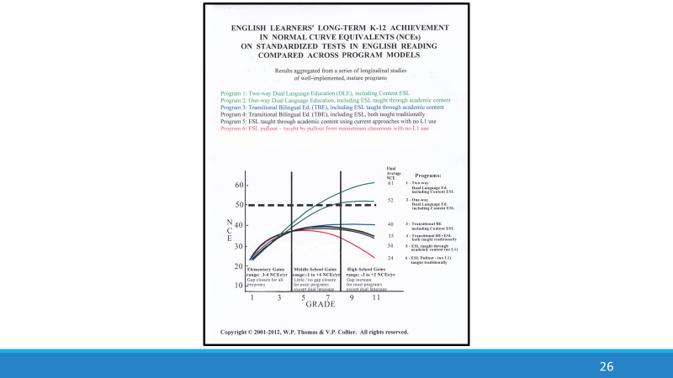
Despite the many benefits of DLI at the secondary level, Spanish home language parents often fear that their child will not acquire the skills necessary to be successful in English. The benefits mentioned above are in addition to English language learners’ achieving high levels of proficiency in English. This graph shows English learners’ achievement levels in English reading in a variety of program models. It represents longitudinal research involving over 15,000 students in different programs and languages across several US states. Longitudinal research means that we’re looking at the same students over time. Let’s look at a larger version of the graphic to better interpret it. | 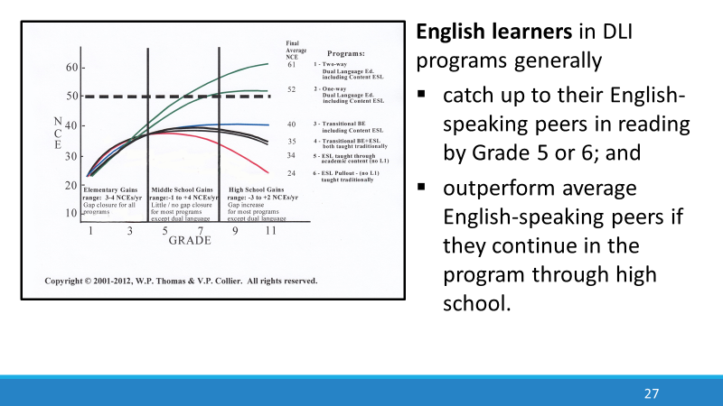  Two-Way DLI programs intentionally bring together students from two language groups – English home language and those who speak the partner language (Spanish) at home. One-Way Dual Language programs - also known as Developmental Bilingual Education - serve language learners with similar language and cultural backgrounds – for example, a group of students who speak Spanish at home. These students have the opportunity to maintain and improve their home language as they learn English. The two-way model shows the best outcomes, and the scores continue to improve from one year to the next.
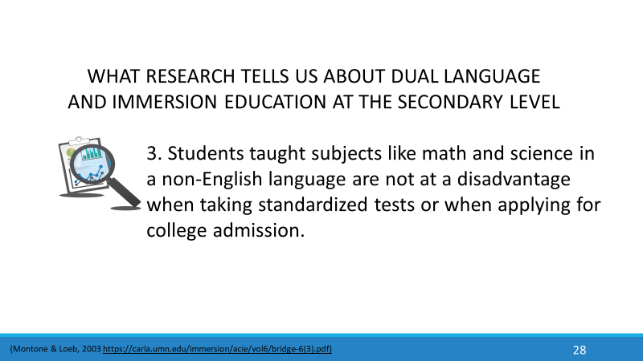  As their children face more serious academic studies, both English and Spanish home language parents may grow more concerned about having their children taught subjects like math and science in a non-English language, fearing that they will not do as well on standardized tests and college entrance exams. | 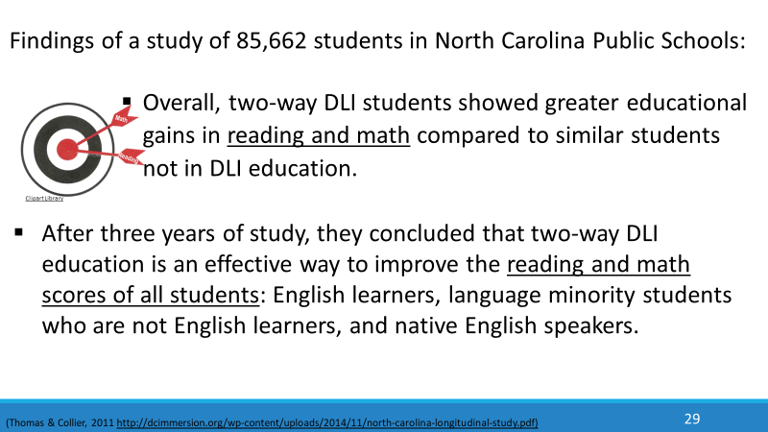  Research over the past five decades has shown similar results. After an initial lag in English literacy skills, DLI students do as well as or better than their non-DLI peers on standardized tests in reading and math, even when the tests are in English and the instruction has been in the immersion language.
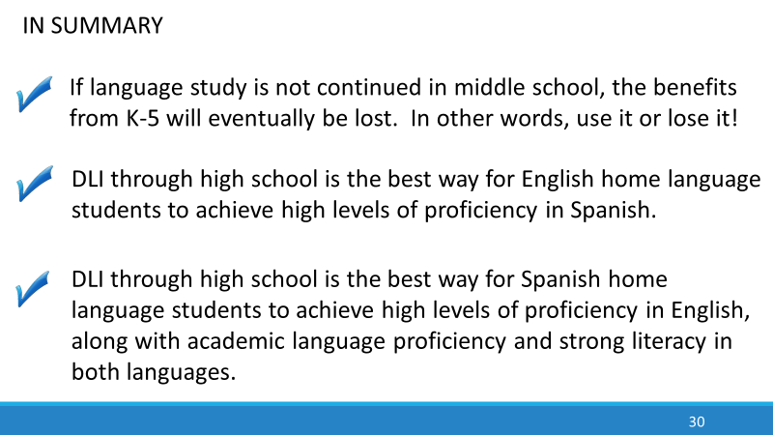 | 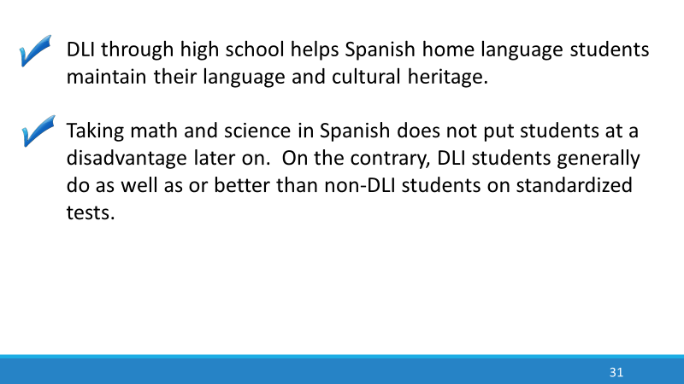
 | 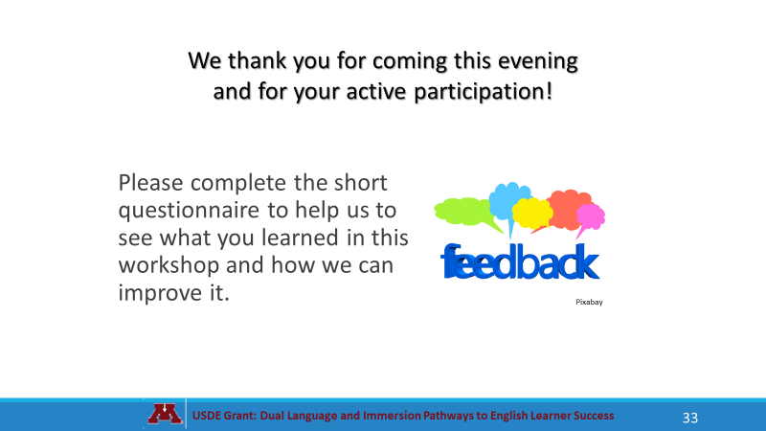
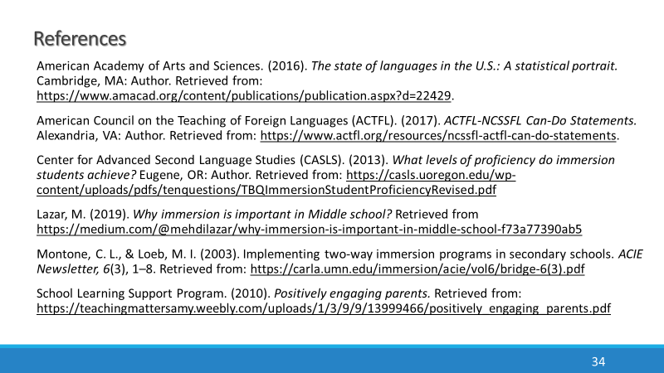 | 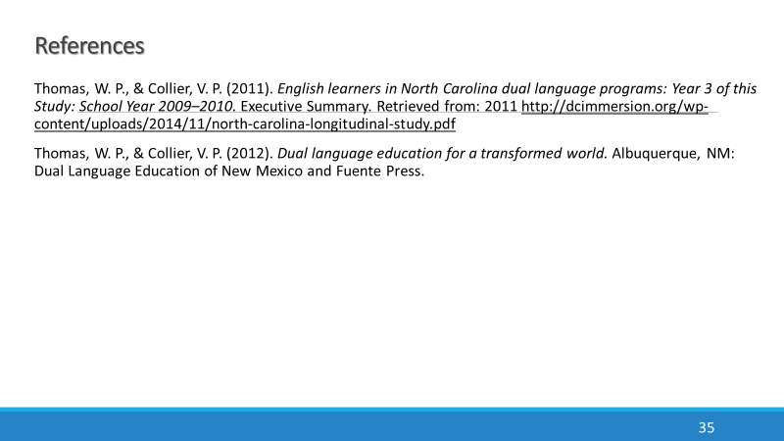
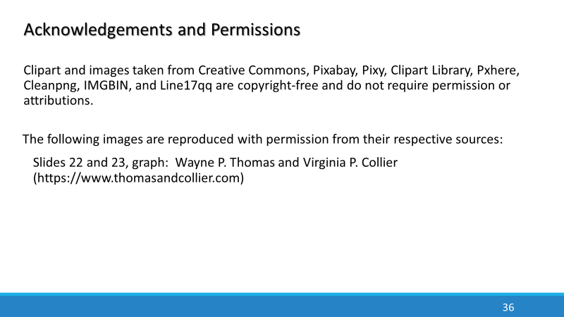 | 