Dual Language and Immersion Family Education:
Supporting Students in Secondary Programs
Session 2
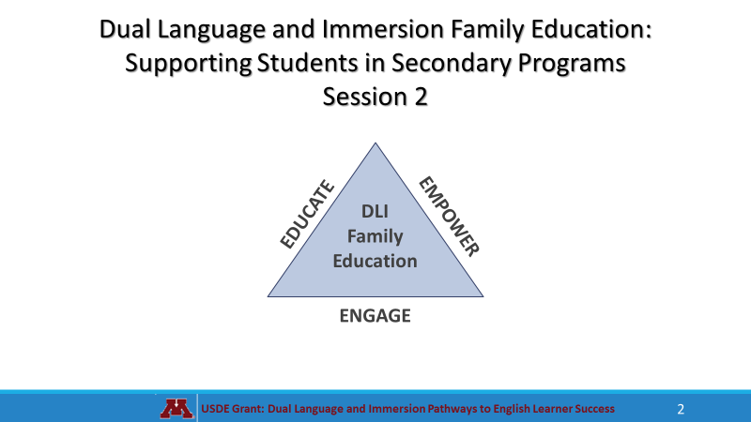 | 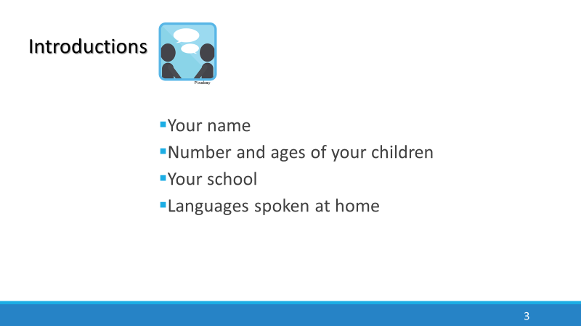
 | 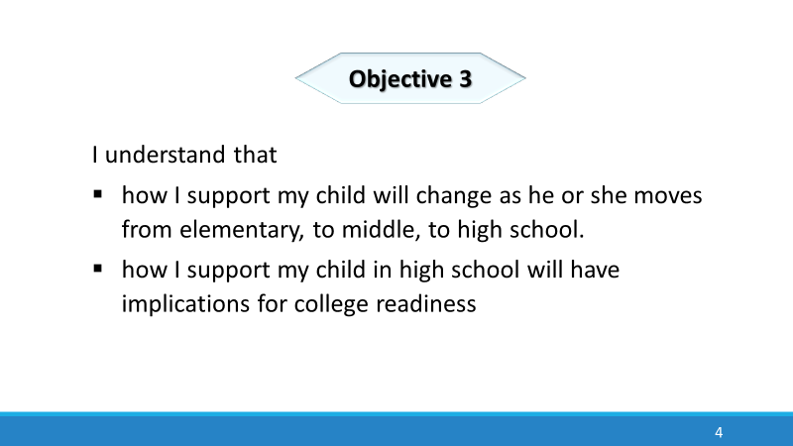
Parental involvement at any level of a DLI program can be challenging. For Spanish home language speakers, there are often linguistic and cultural barriers to overcome, while English home language speakers are uncertain of their role if they do not speak Spanish. Nevertheless, at the elementary level, families commonly assist with homework, eat lunch at school, volunteer as reading tutors, room parents, field trip chaperones or classroom helpers. Involvement at the secondary level, however, looks quite different.
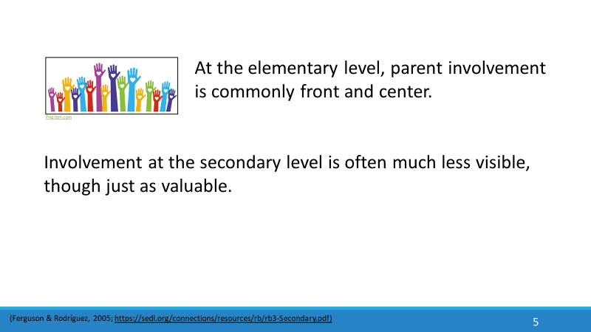  Parental involvement at any level of a DLI program can be challenging. For Spanish home language speakers, there are often linguistic and cultural barriers to overcome, while English home language speakers are uncertain of their role if they do not speak Spanish. Nevertheless, at the elementary level, families commonly assist with homework, eat lunch at school, volunteer as reading tutors, room parents, field trip chaperones or classroom helpers. Involvement at the secondary level, however, looks quite different. | 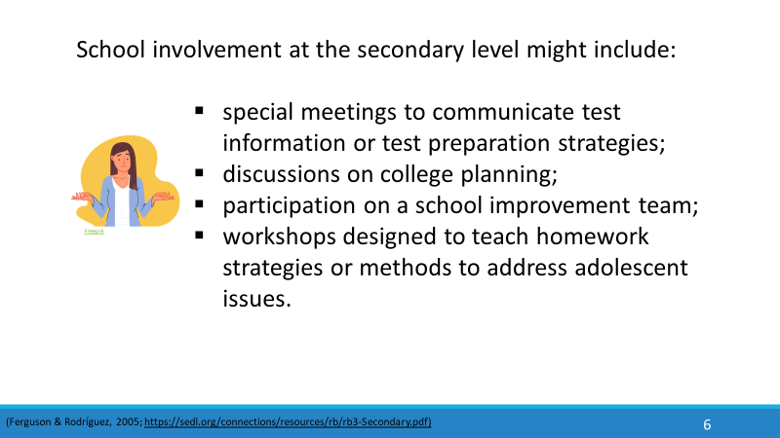  This kind of support can be daunting, especially for families who have not gone through test preparation and the college planning process themselves.
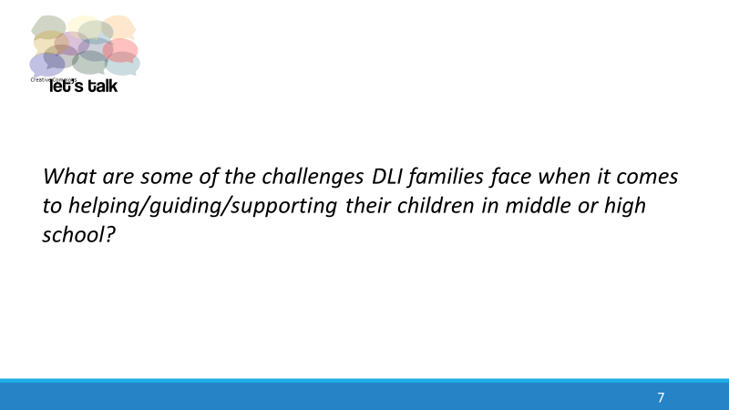  The first four points are things all parents can do, right now. | 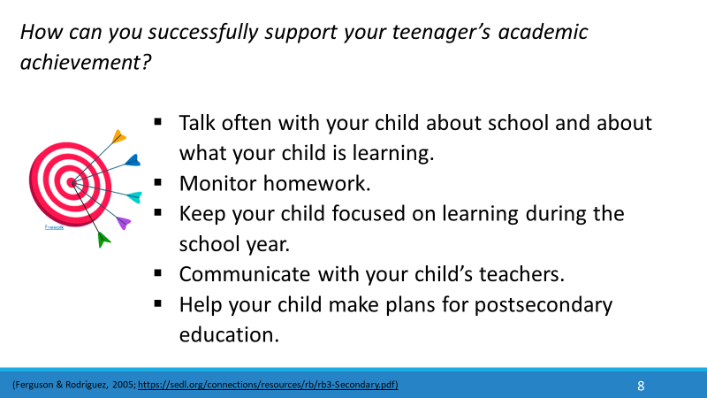  The first four points are things all parents can do, right now.
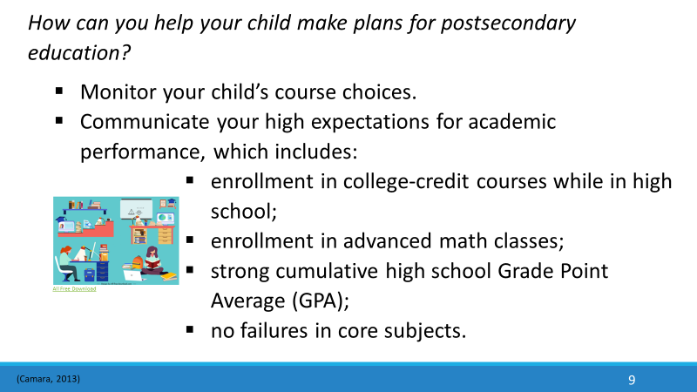 | A semester GPA is an average of the grades a student receives in a given semester. A cumulative GPA is an average of the grades a student will have received in all courses throughout high school.  It is important that you encourage your child to enroll in advanced math classes and college-credit courses. There are a number of ways that your child can receive high school and college credit at the same time.
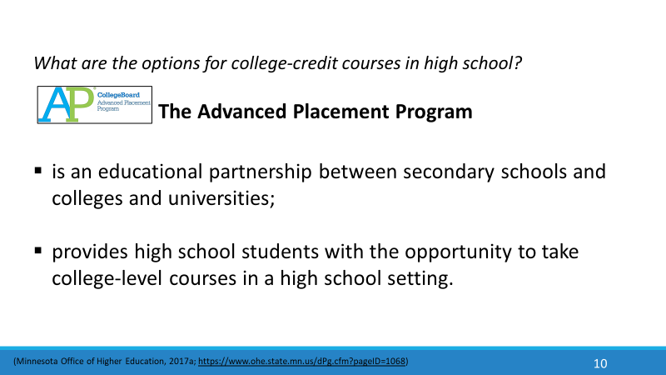 | 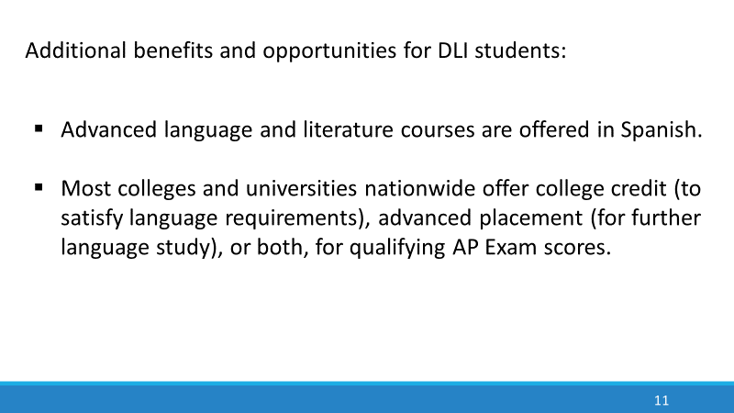
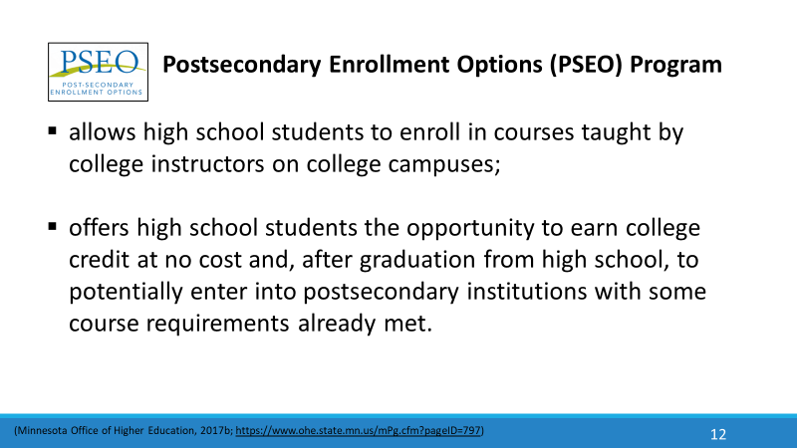 | 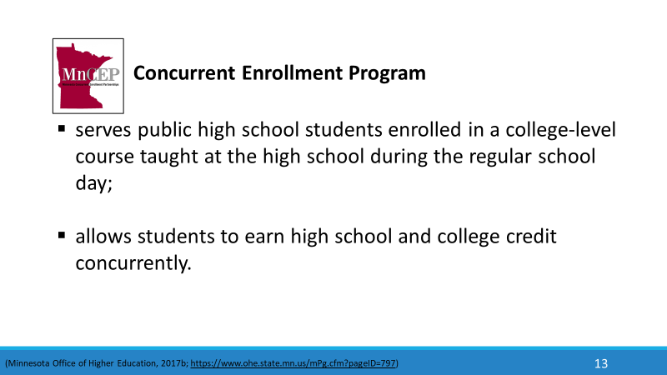
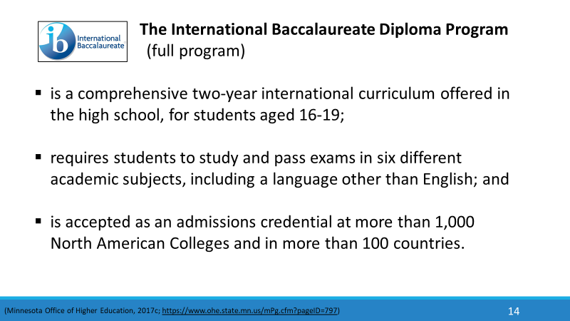 | 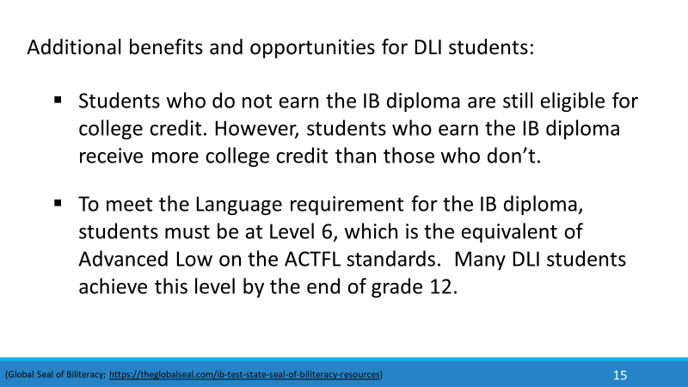
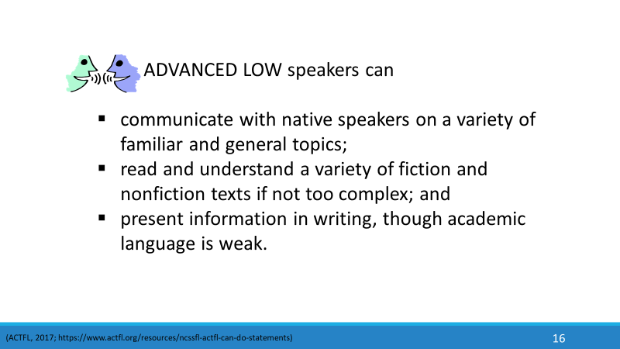 | 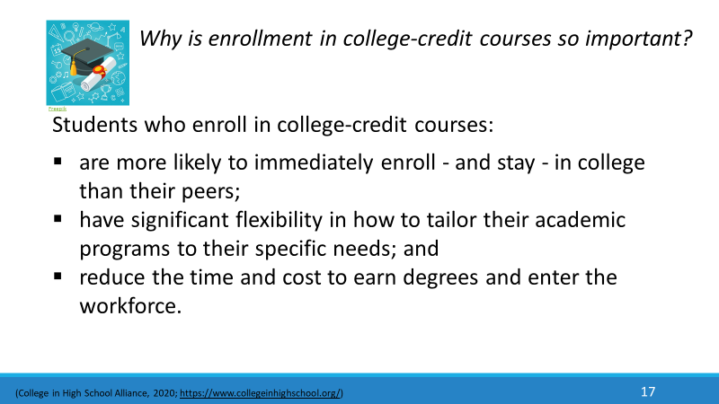
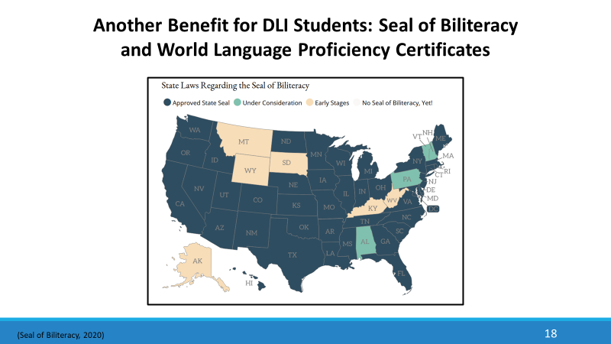  The first Seal of Biliteracy was created in 2008 as part of a grassroots effort by the nonprofit group, “Californians Together.” Their goal was to recognize high school graduates who had obtained high levels of competency in one or more languages in addition to English. The seal has gained in popularity throughout the United States in recent years. | 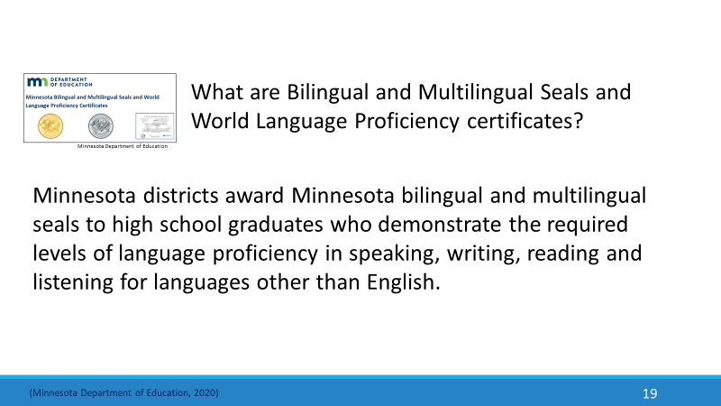
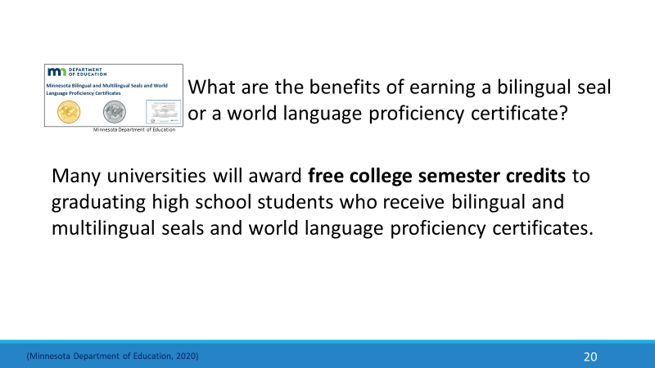 | 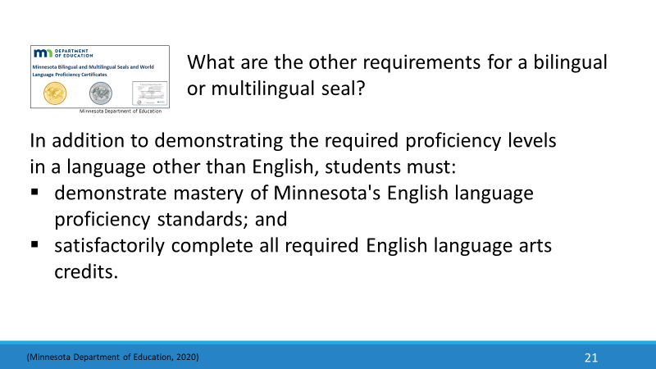
 | 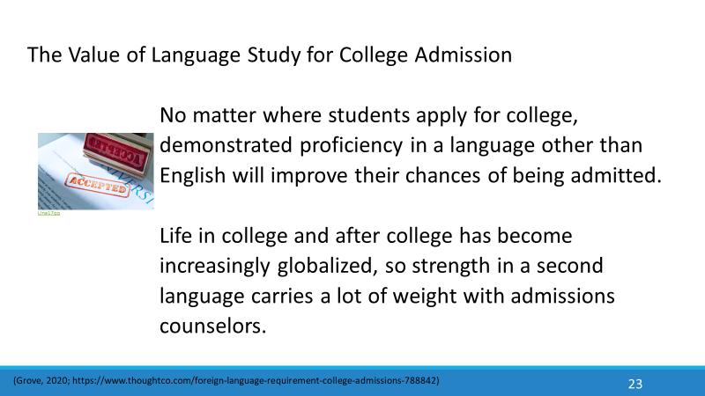
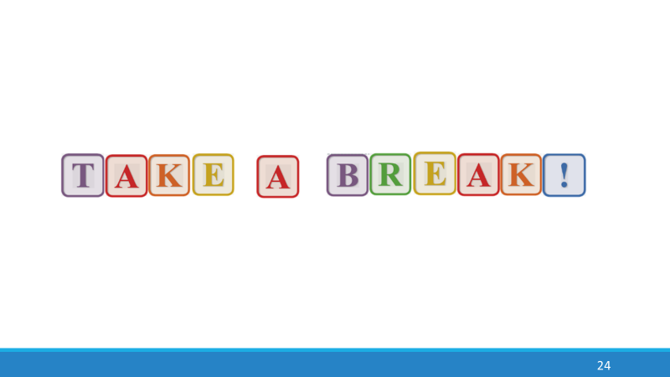 | 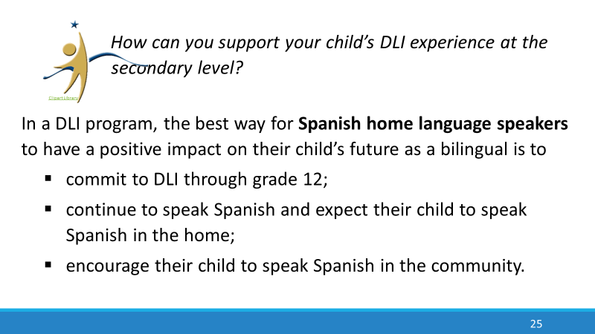  When students see that their parents value their language and culture, they are more likely to embrace those values themselves and are more motivated to continue in the DLI program through grade 12.
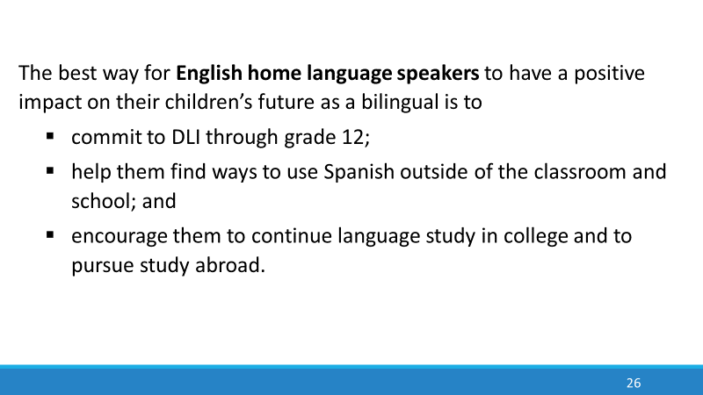  The more students use their language in culturally authentic contexts, the more they begin to see a future for themselves as bilinguals and the more motivated they are to pursue advanced language study in college. | 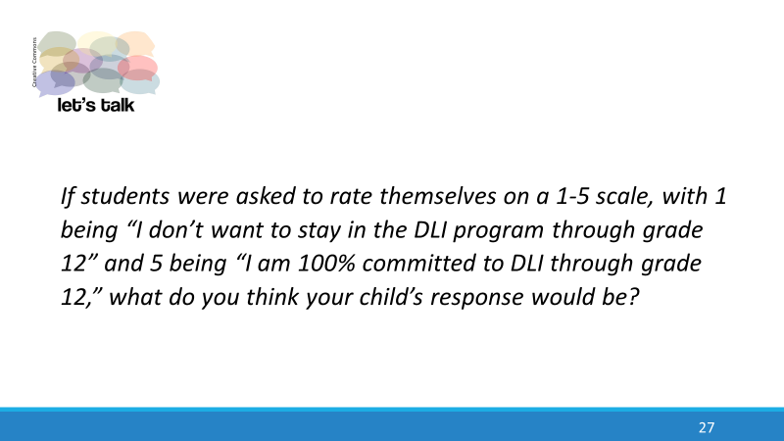
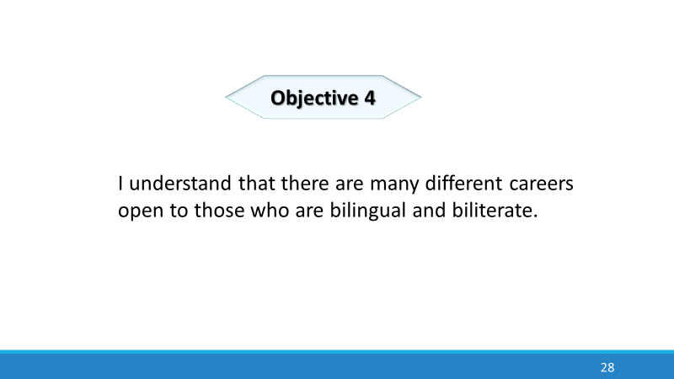 | 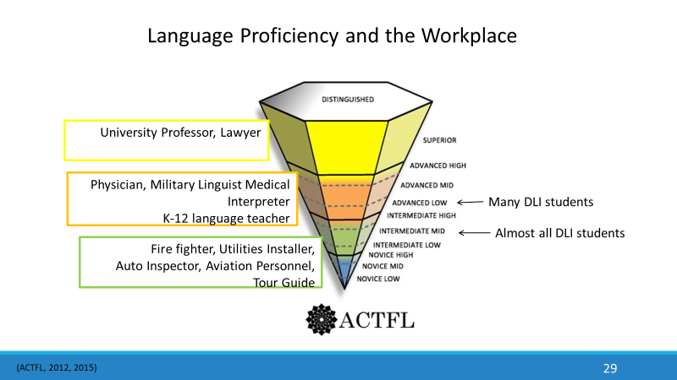
Enrolling your child in a DLI program is not enough to ensure the level of proficiency necessary for the most demanding careers, such as physician or lawyer. However, you are setting your child on a solid path to a bilingual future. We have already seen that almost all DLI students who remain in the program from kindergarten through grade 12 achieve proficiency in the Intermediate Mid range and many immersion students even reach the Advanced Low range by the end of grade 12. But in order to achieve the high level of language proficiency required to work in a bilingual environment, students will need many additional opportunities to use Spanish and will have to continue formal study of the language as well. This graph shows some traditional careers for today’s bilinguals. There will be many other careers for bilinguals in the future that don’t even exist today.
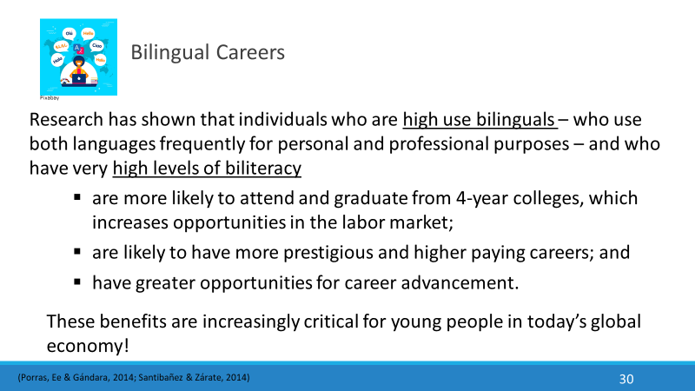 | In fact, a study in Belgium found that balanced bilinguals earn about $5,200 more annually at the beginning of their careers than do monolinguals – the findings were the same for different language groups. So there is a substantial loss to a person in earnings over time if they lose the home language.
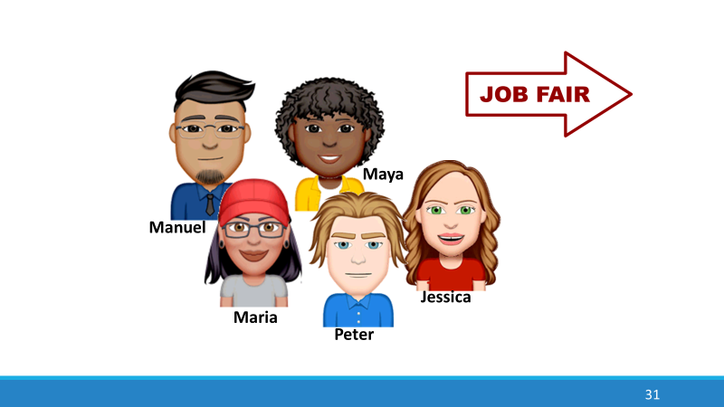 | 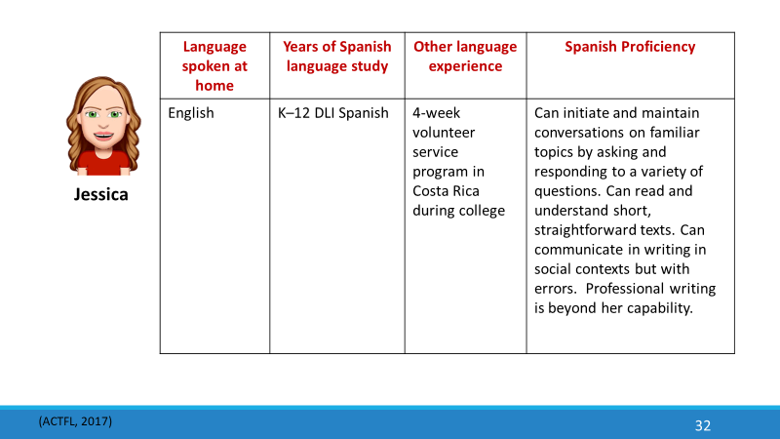
This activity will help you make the connection between language proficiency and actual careers.
Five recent college graduates are attending a job fair. All attended DLI programs growing up. Can you match them with their future career possibilities?
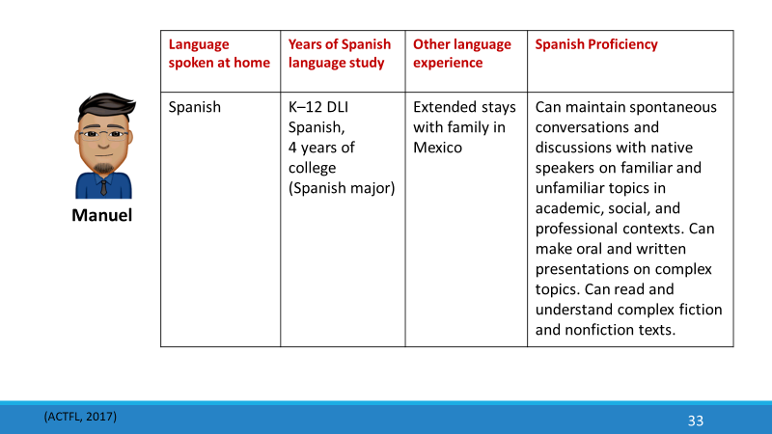 | 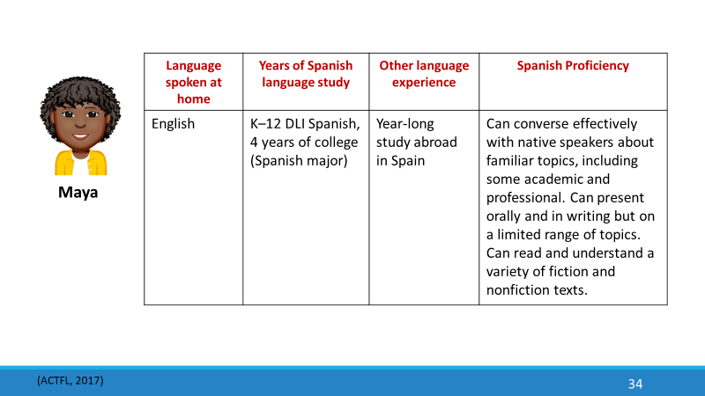
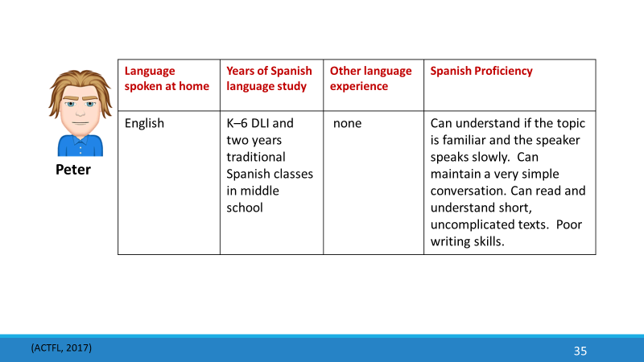 | 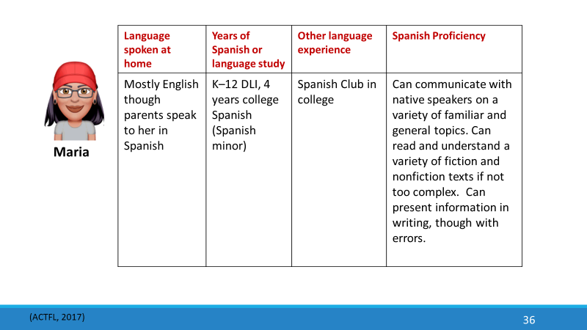
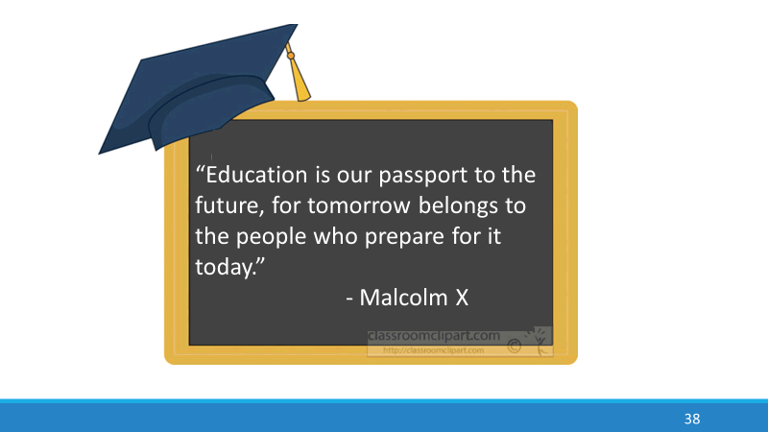
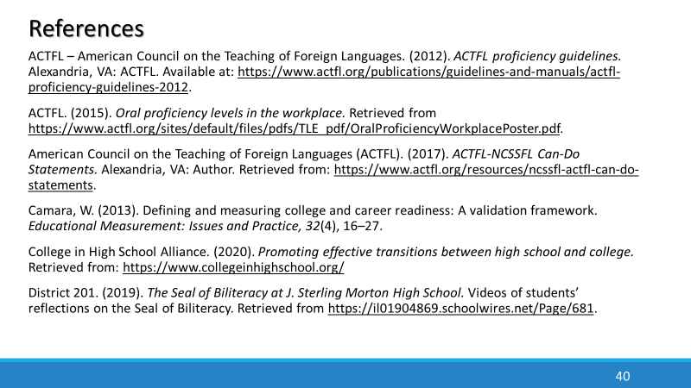 | 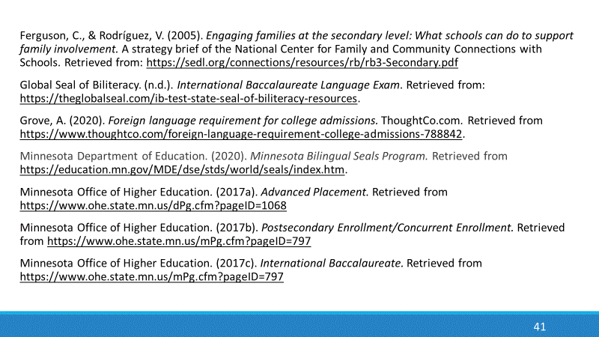
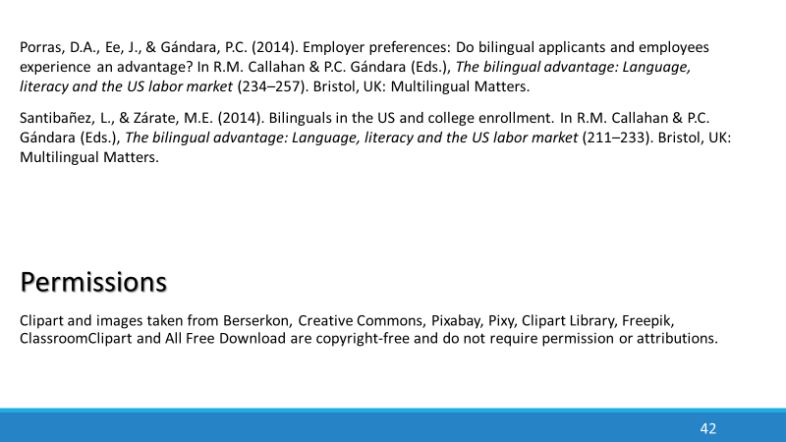 | 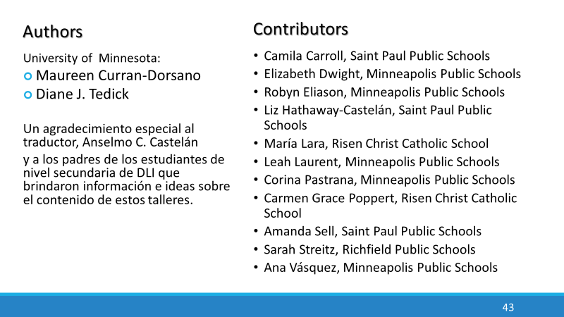
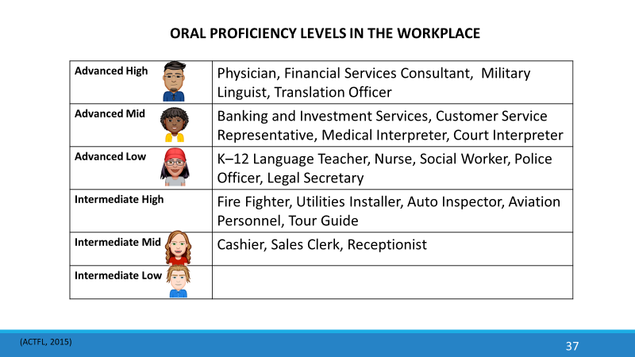 Spanish home language speakers like Manuel who continue to speak Spanish in the home, spend extended periods of time in a Spanish-speaking environment and continue their Spanish studies in college are the most likely to achieve high levels of proficiency.  English-language speakers like Maya need four years of advanced Spanish in college and an extended stay in a Spanish-speaking country | if they are to achieve the high levels of language proficiency and cultural competence necessary for a bilingual career.  Students like Maria may have good speaking skills, but they still need advanced language study in college to acquire the necessary academic language and writing skills required in higher level careers.  Students at the Intermediate Mid level like Jessica may be able to get by orally if the task is not too demanding, but they are limited in their use of the language and their skill level would have low marketability.  Students like Peter are out of luck! Staying in the program through high school is the minimum requirement, even for low-level jobs.  All candidates can improve their skills just by using their language every day at home, in their jobs, traveling, reading or watching TV/movies in Spanish, etc. But if they do nothing to maintain and further develop their language skills during their four years of college, much of the proficiency gained during their K-12 DLI education will be lost by the time they are ready to enter the workforce.

