SESSION 2: BILINGUALISM & BILITERACY

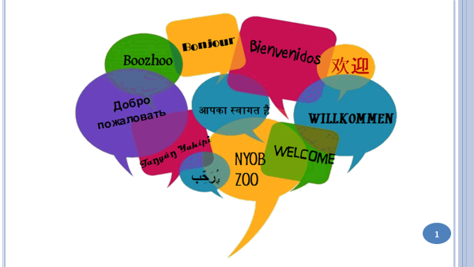 | 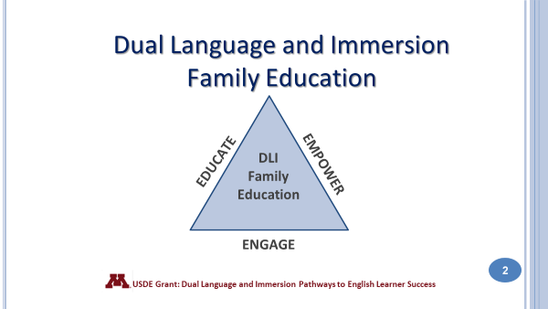
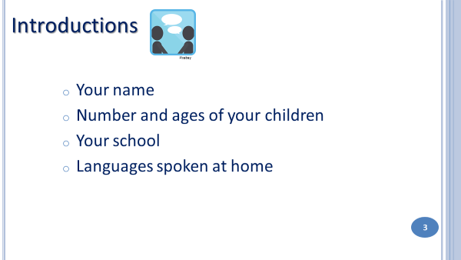 | 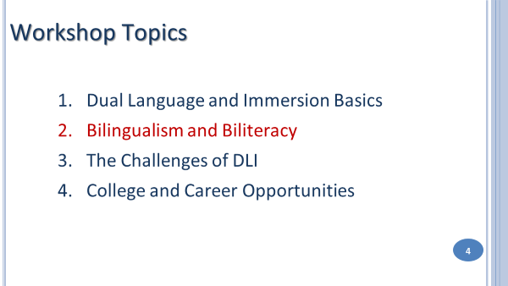  Tonight’s topic is Bilingualism and Biliteracy and how we can help our children achieve those two goals.
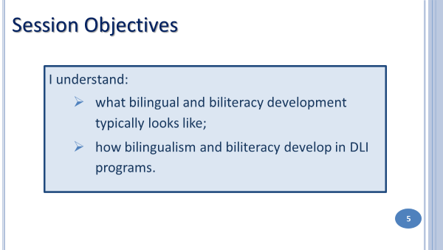 | 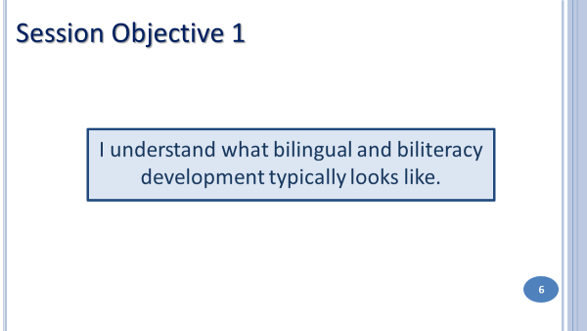
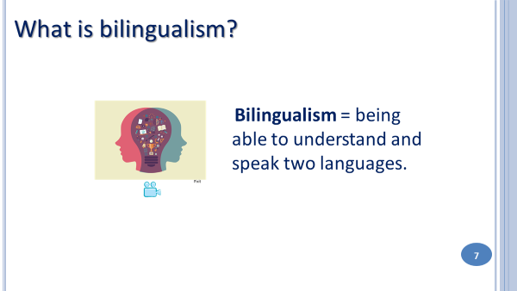  Some of you here tonight are bilinguals, hoping to pass that on to your children. Others of you want to offer your children a language you never had a chance to acquire. All of you see the value of speaking another language, which we can see in this video clip. | 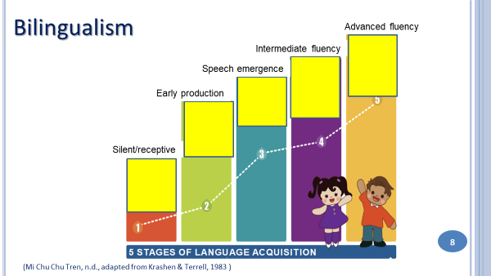  What does typical bilingual development look like? Here are 5 statements that describe each stage of language acquisition or language learning. At your table, see if you can put the statements in the right order from the first stage to the last one.
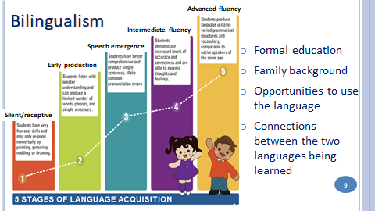  Every language learner goes through these five typical stages of language learning. But each learner is unique and it may take more time for some to reach high levels of proficiency in both languages. There are several factors that can affect one’s language learning journey. These factors include:  - Formal education in the language. Going to school in a DLI program sets your child on the path toward bilingualism.  - Family Background. If your family language is represented in the DLI program (Spanish), your child will be more motivated to speak that language both at home and at school. She will have more opportunities to use the language with family members and in the community. | - Opportunities to use the language. We know that people learn languages by using them so we need to ensure that children have many different kinds of opportunities to use the languages they’re learning with different types of people. This is true for both English-language speakers and Spanish-language speakers. It may be face-to-face interactions with speakers of the partner language, films, online games, cultural events or travel opportunities. There are lots of ways to create opportunities for children to use the languages they’re learning.  - Connections and similarities between the two languages. English and Spanish have many similar words – family/familia, television/televisión , so in some ways Spanish speakers might learn English a little more easily because of the close relationship between Spanish and English. The same is true for English language speakers learning Spanish.

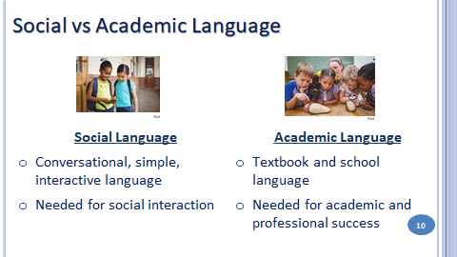  For Spanish-speaking children, social language begins at home. At school, social language is used at recess, in the lunchroom and on the bus. For English-speaking students, social language in Spanish is much more difficult to learn, since it must be taught in the same way that academic language is taught. | Academic language is the language used in formal learning in school and textbooks. Examples of academic language are words such as "therefore," "however," "as a result," for example, and all vocabulary related to content areas such as math and science.  Academic language is really important for success in school and in the professional world and it takes, at least, 5 to 7 years to acquire it. This is one more reason why it is so important that students remain in the DLI program through high school and continue their study of the language even further.
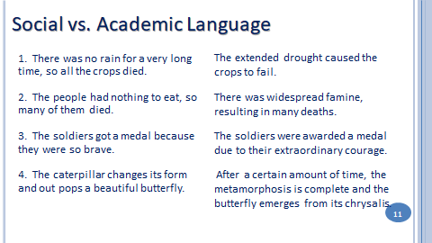 | Social and academic language can also be thought of in terms of informal versus formal, or simple versus complex.  In the early grades, the language of instruction is more social in nature. Students begin by talking about themselves, their families, their pets, and even the instructional language in math or science is very simple. As students move up in the grades, concepts become more complex and the language becomes much more academic. Here are some examples of the two kinds of language.
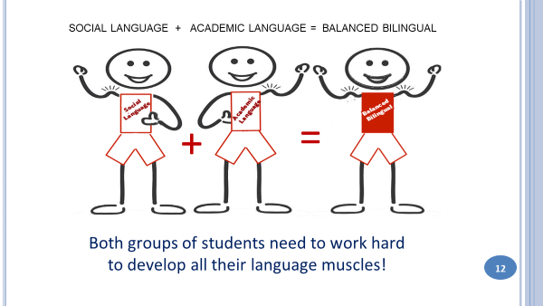 | 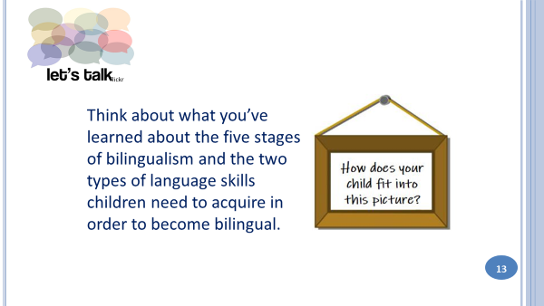
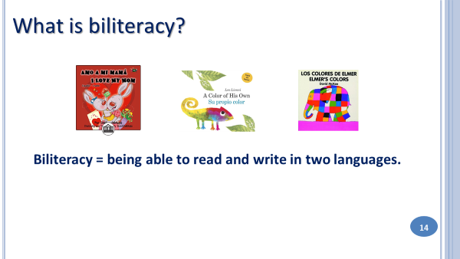 | 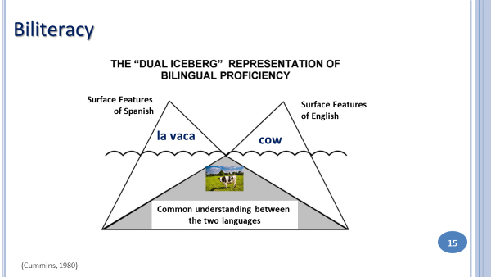
To understand how bilingualism and biliteracy work, we can use the Dual Iceberg Representation of Bilingual Proficiency. Let’s imagine some icebergs – we know that the part of the iceberg that we see above the surface of the water is only a small part – underneath the water is a much larger part of the iceberg. In this figure, the part of the iceberg that’s below the surface of the water represents the common knowledge that crosses languages. Above the surface are two peaks or the part of the iceberg that we can see. They represent the things that are different between the two languages. The words for “cow” are different in the partner languages, but the idea of “cow” is the same. The same thing applies to reading. Students have to learn how to read the word vaca, but they don’t have to learn what a cow is since they already know what a cow is.
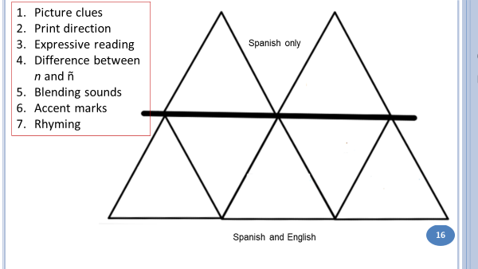 | Students also rely on many reading strategies that they have already learned in one language in order to read in the other language. So children aren’t learning everything all over again – they just learn a new way to express the concepts in the new language. Here are some examples of early literacy reading concepts. Some are “above the surface” – they have to be learned for a particular language. Some are “below the surface” and can be transferred from one language to another.
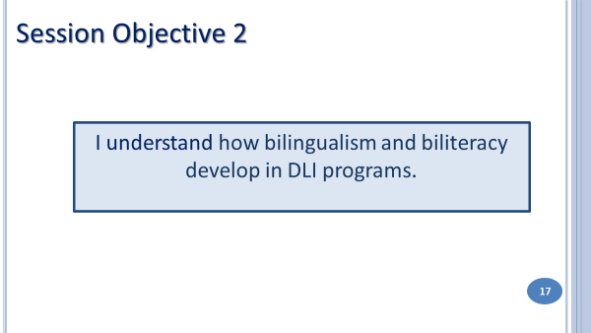 | 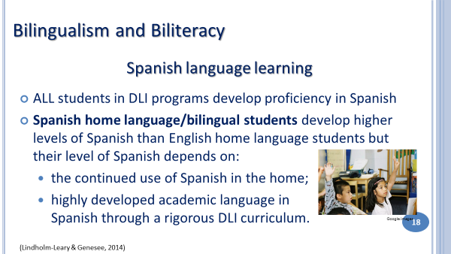
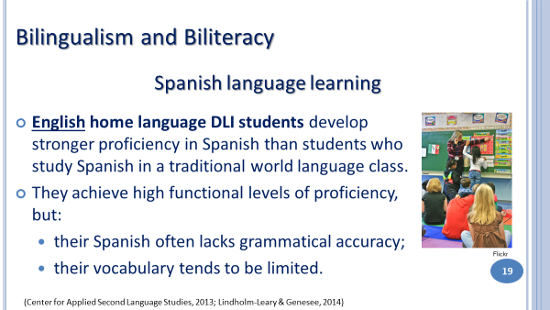 | 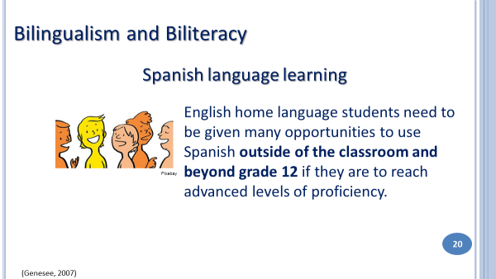
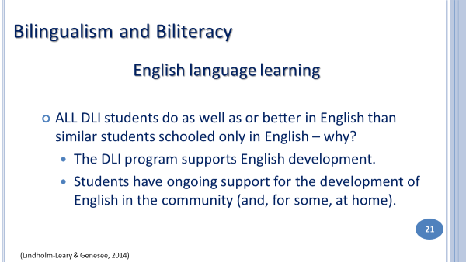 | 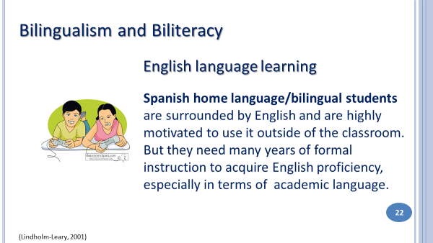
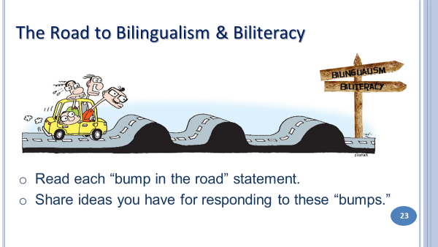 | 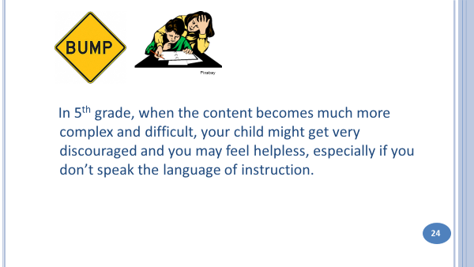
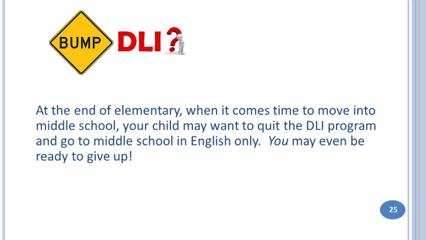 | 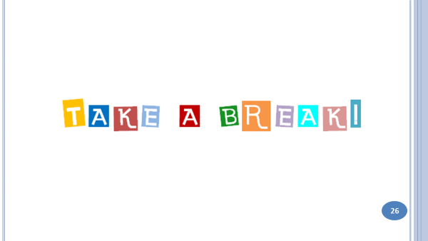
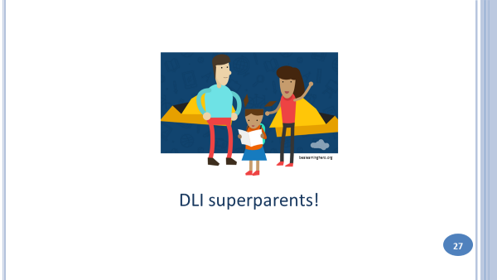  Enrolling your child in a DLI program is not enough to ensure that your child will be bilingual and biliterate. Parents have an important role to play – and it will be different depending on whether your home language is English or Spanish. | 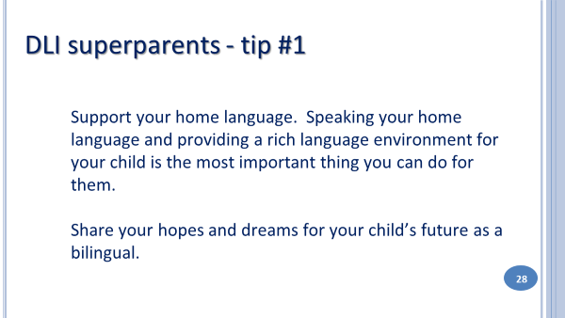
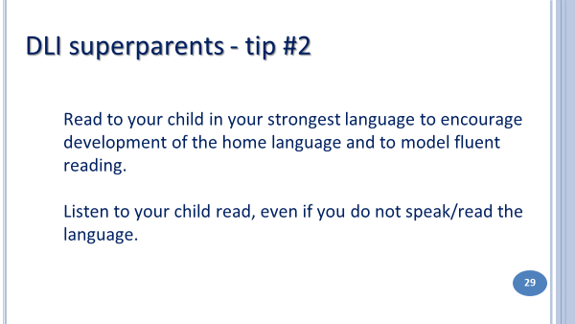 | 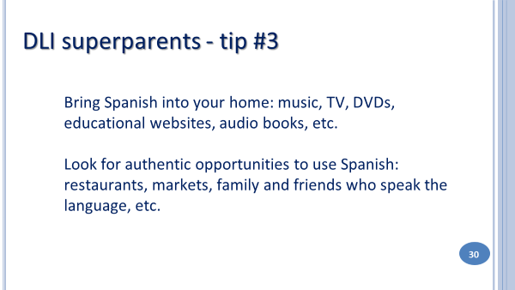
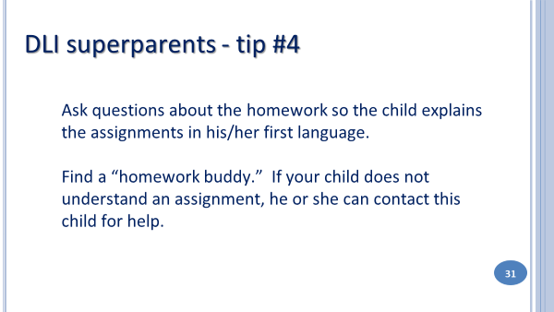 | 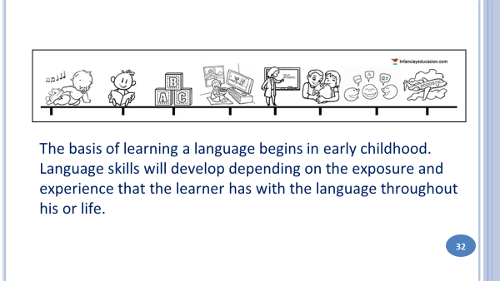
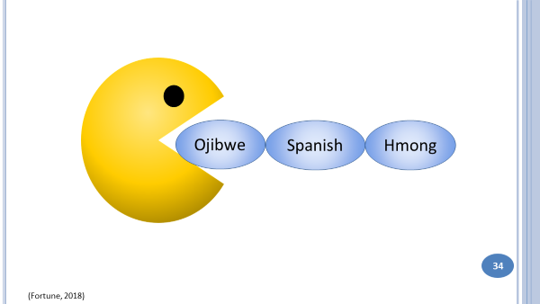
In the U.S., English is the Pac-man of all languages! Across the United States we have tens of thousands of children who come into our school system as bilinguals and leave the system as monolinguals. This break with the language oftentimes means a loss of cultural identity as well.
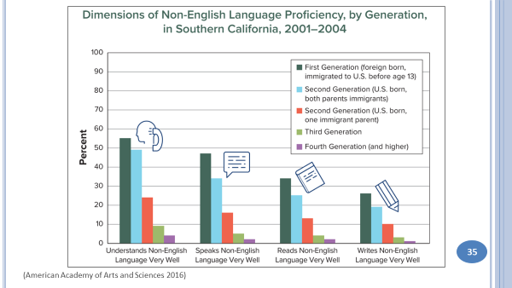 | For immigrant families, the ability to understand, speak, read, and write the home language disappears very quickly. A study in Southern California found that only 45% of first-generation adults who immigrated to the United States before the age of 13 could still speak the language of their parents well. Only 35% of second- generation immigrants could speak their home language. And only 5% of third generation immigrants could speak the language of their grandparents. Without making a conscious effort to maintain it, families can lose their home language in 3 to 4 generations, showing just how powerful English is in the U.S.
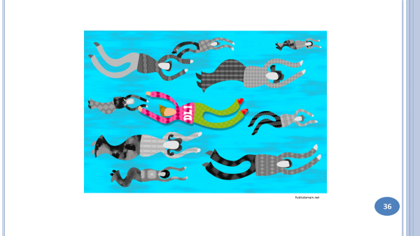 | If you are an English home language parent, you have different challenges. Despite the tremendous growth in Dual Language and Immersion programs over the last 45 years, you are still swimming against the tide. Most Americans - who could include your family, friends and coworkers - don’t know about, don’t understand or don’t agree with DLI education and you may be criticized for the choice you made. Your child will also have a harder time developing high levels of proficiency without additional exposure to the second language.
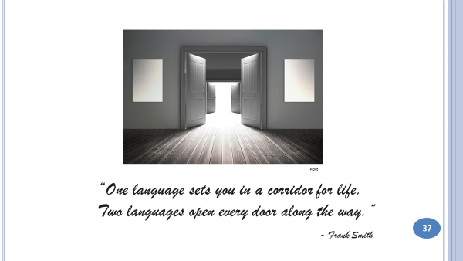 | 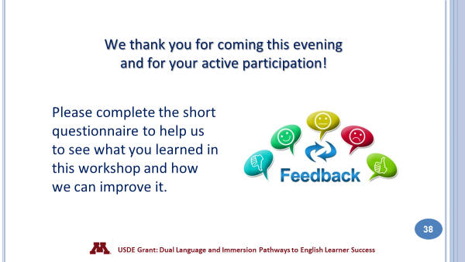
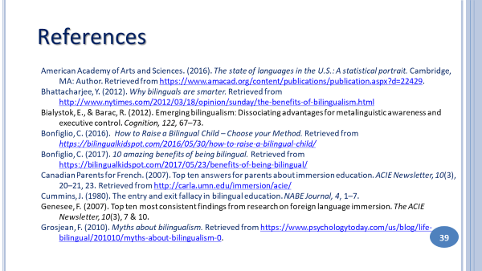 | 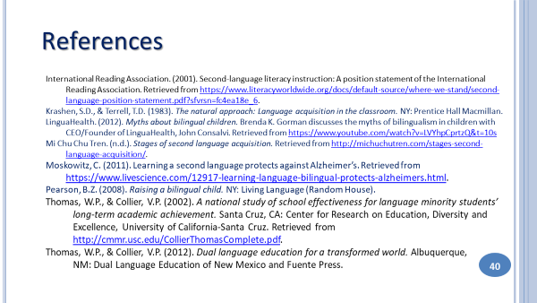

Answers to discussion questions
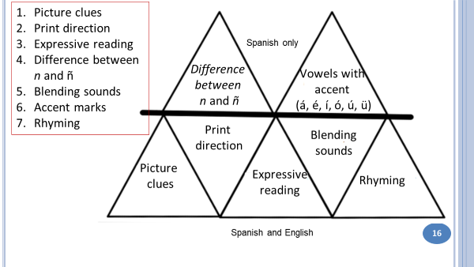 | 