I: QHOV CHIV NTAWM KEV KAWM OB HOM LUS
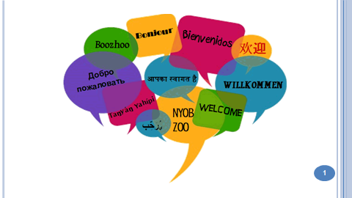 | 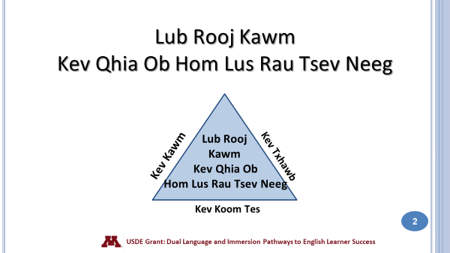
Ua tsaug nej sawv daws tuaj hmo no. Peb cia siab tias nej yuav nyiam thiab txaus siab rau cov kev kawm peb npaj tuaj qhia nej hmo no. Peb sawv daws sib cog kawm mus, yog nej tsis tau taub qhov twg los yeej meem nug.
The Dual Language and Immersion Family Educationv program is supported by a United States Department of Education grant from the Office of English Language Acquisition.

Lub Rooj Kawm Kev Qhia Ob Hoom Lus Rau Tsev Neeg tau txais kev txhawb ntawm United States Department of Education uas yog ib qhov grant los ntawm Office of English Language Acquisition.

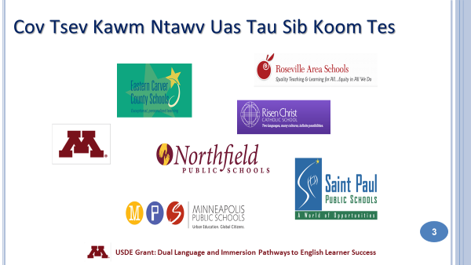 | 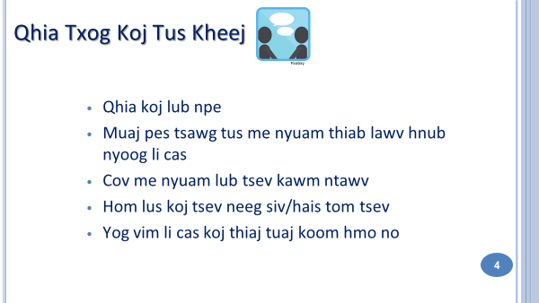
Hais txog ntawm pob nyiaj, lawv muab rau lub tsev kawm ntawv qib siab, University of Minnesota tau muab coj los sib koom tes nrog lwm cov tsev kawm ntawv xws li: Eastern Carver County Schools, Minneapolis Public Schools, Northfield Public Schools, Risen Christ Catholic School, Roseville Area Schools, and Saint Paul Public Schools.
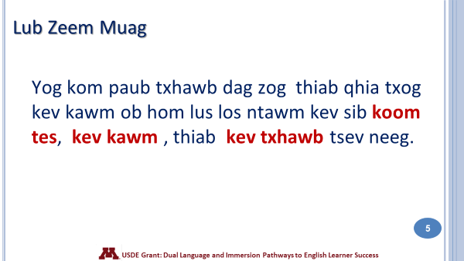 | 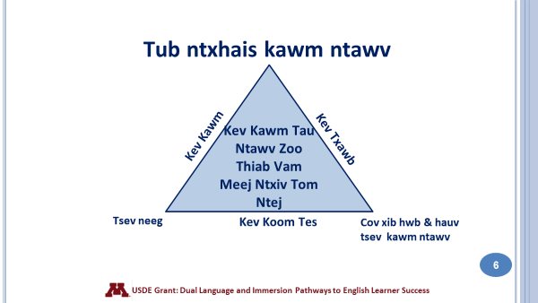

Qhov no txhais tau li cas?
- Qhov ib, cov tub ntxhais kawm ntawv, cov tsev neeg, cov xib hwb thiab lwm cov neeg hauv tsev kawm ntawv sib koom tes txhawb kom cov tub ntxhais kawm tau ntawv zoo lawm tom ntej. Nco cia: taw qhia thiab tham txog 3 lub ces kaum ntawm lub ntsais no.
- Tseem ceeb heev rau koj ua niam ua txiv txoj kev txhawb koj tus me nyuam txoj kev kawm ob hom lus. Qhov ib, koj yuav tau sib koom tes nrog tsev kawm ntawv, cov xib hwb thiab koj tus me nyuam txoj kev kawm. Kev koom tes zoo tib yam li thaum yus cog lus los npaj pib yus lub neej. Yuav tau sij zog ntso, mob siab, thiab rau siab tshwj yus lub neej kom zoo.
- Qhov 2, koj yuav tau kawm kom paub kom tus me nyuam txoj kev kawm ob hom lus kom zoo zoo thiab meej meej ces koj thiaj paub nug thiab nrhiav kev los pab koj tus me nyuam.
- Qhov 3, yog koj kawm thiab paub zoo txoj koj tus me nyuam txoj kev kawm ces koj muaj lub peem xwm thiab muaj cai mus hais thiab tawm suab los nrhiav kev pab koj tus me nyuam thaum nws kawm ob hom lus. Peb yam hais tag los no yog txoj kev koj tus me nyuam yuav kawm tau zoo thiab vam meej mus lawm tom ntej.
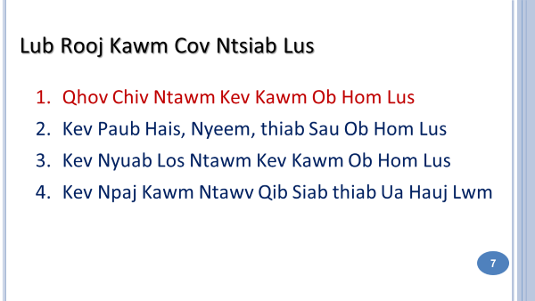  Ntawd no yog plaub lub ntsiab uas yuav muab coj los qhia rau Lub Rooj Kawm no. Peb ntseeg tau thiab vam tias nej yuav tuaj kawm tag nrho plaub lub ntsiab kawm uas peb npaj tau no. | - Kev kawm ob hom lus no txhais tau li cas? Qhov tseem ceeb ntawm kev kawm ob hom lus yog dab tsi?  - Kev paub ob hom lus thiab paub sau nyeem ob hom ntawv txhais tau li cas? Yus yuav pab tus me nyuam li cas kom nws paub ob hom lus thiab paub sau nyeem ob hom lus?  - Cov kev yuav nyuaj rau tus tub ntxhais kawm ntawv thiab lawv tsev neeg muaj li cas thaum lawv xaiv kev kawm ob hom lus.  - Kev paub ob hom lus thiab paub sau nyeem ob hom lus yuav pab tau koj tus me nyuam li cas rau yav neej pem suab?

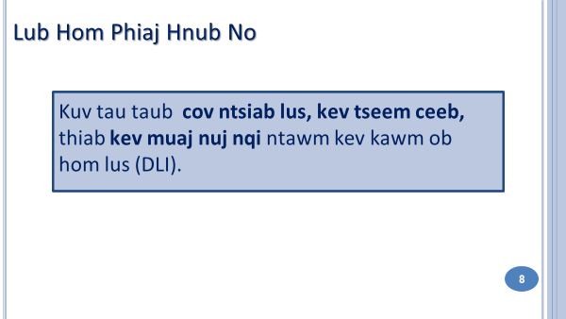  Peb muaj ib lub hom phiaj kom nej paub rau hmo no: Rau kom nej tau tau cov hom phiaj thiab cov ntsiab lus ntawm kev kawm ob hom lus. Peb yuav siv cov tsiaj ntawv“ DLI”no los sawv cev rau kawm ntawv ob hom lus. “DLI language” thiab Partner Language” hais txog lus Mev los yog lus Hmoob. |  | 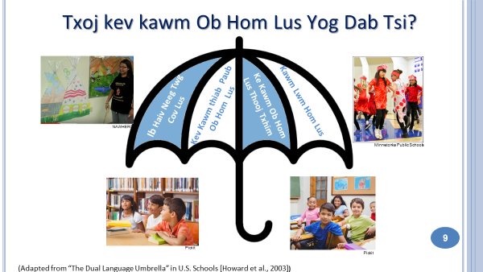  Kev kawm ob hom lus yog txoj kev txhawb nqa txhab kev paub ob hom lus- uas kom cov me nyuam paub ob hom lus zoo zoo thiab meej meej ib yam nkaus tsis hais lus Askiv los yog lus Hmoob.  Kev kawm ob hom lus muaj 4 txoj kev kawm nyob rau hauv lub kaus kawm ob hom lus.
- Indigenous/Heritage language immersion: Cov kev kawm (Programs) no tsim muaj los cawm los yog ceev cov neeg khab tej lus, tej kev lis kev cai thiab tej txuj ci cia. Lawv tsuas qhib rau cov tub ntxhais kawm ntawv uas yog los ntawm caj ces ntawd xwb. Nyob rau lub xeev Minnesota lawv muaj cov kev kawm cov khab Ojibwe thiab Dakota cov lus.
- Developmental Bilingual Programs: Cov kev qhia ob ho lus no pab rau cov tub ntxhais uas txawj hais tib co lus thiab muaj kev li kev cai zoo tib yam – muab piv txwv, Ib pab tub ntxhais uas hais lus Mev nyob tom vaj tom tsev. Lawv muaj lub cib fim ceev lawv cov lus cia thiab txhim kho kom lawv cov lus zoo dua qub thaum lawv tab tom kawm Askiv. Nyob hauv xeev Minnesota cov Kev qhia ob hom lus li no puav leej rau neeg Mev xwb.
- One-Way World Language Immersion: Qhov kev kawm no yog tsim los qhia cov tub ntxhais uas hom lus lawv tham tom vaj tom tsev yog Askiv. Nyob hauv xeev Minnesota lawv muaj (one-way programs) rau neeg Mev, neeg Fab Kis, neeg Ntsaws Mes Nis, neeg Suav thiab neeg Kaus Lim. Ces thaum kawg no, yog qhov kev kawm (program) uas yuav coj los qhia hmo no.
- Nws yog qhov kev Kawm Ob Hom Lus (Two-Way Immersion program) Nws zoo li muab ob qhov kev kawm (developmental bilingual and one-way world language immersion) tso ua ib qhov xwb. Vim nws coj cov tub ntxhais ntawm ob qhov kev kawm no los kawm ua ke – Cov hais lus Askiv thiab cov hais lawv thawj thawj hom lus (Hmong los yog Mev) tom vaj tom tsev. Tsis tas li ntawm kev qhia ntawv rau cov tub ntxhais los yog siv ob hom lus qhia (Askiv thiab Hmong los yog Mev).
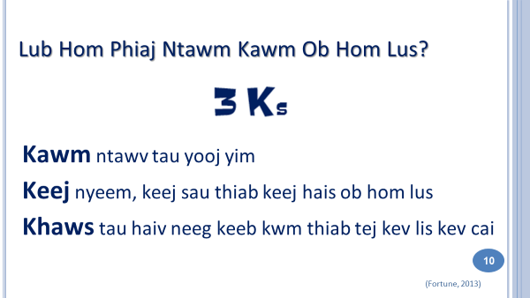 | 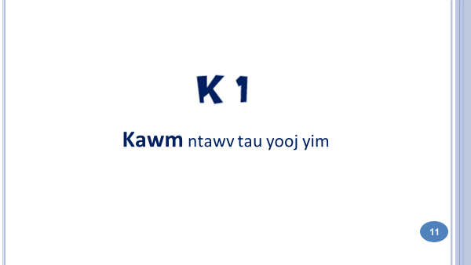
Peb rov saib peb kawm li cas lawm. Peb lub hom phiaj ntawm kev kawm ob hom lus. Hmo no peb tham txog kev kawm thiab xeem tau ntaub ntawv. Lwm lub lim tiam peb yuav kawm txoj kev paub nyuam, sau, thiab hais ob hom lus. Ua ntej peb xaus hmo no, peb xav hais ob peb lo los txoj kev paub haiv neeg kab li kev cai thiab keeb kwm.
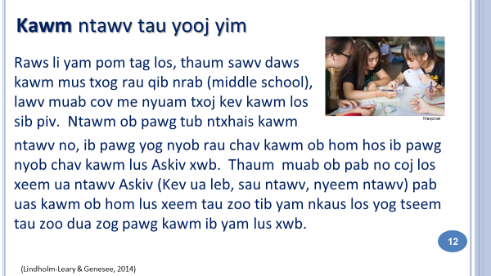 | 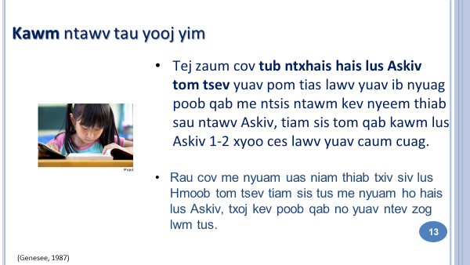  Rau cov tub ntxhais uas hais lus Askiv tom tsev tiam sis niam txiv yog Hmoob thiab kawm lus Askiv tom qab, yuav siv sij hawm ntev me ntsis thiaj li caum cuag.
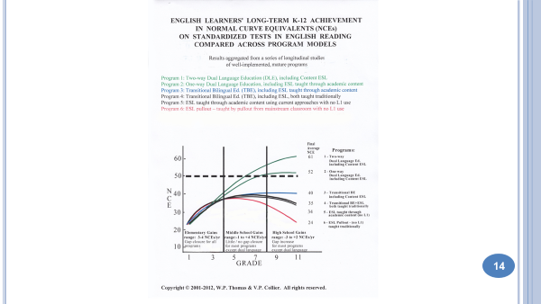 | 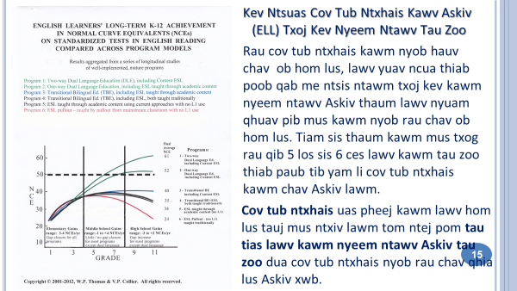
Rau cov Hmoob qhia lub rooj kawm: Ib zaum ntxiv, peb yuav muab piv txwv tau tias rau cov me nyuam Hmoob kawm rau chav kawm ob hom lus ces mus txog tim yam yog tias lawv taug tib txoj kev kawm li kev kawm ob hom lus.
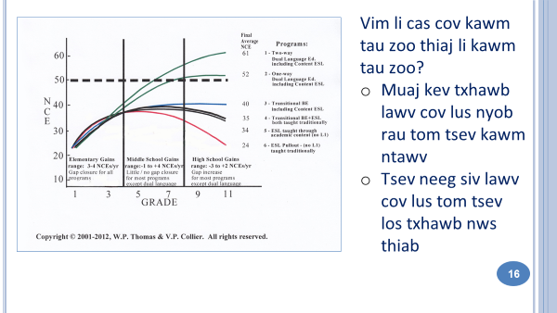 | 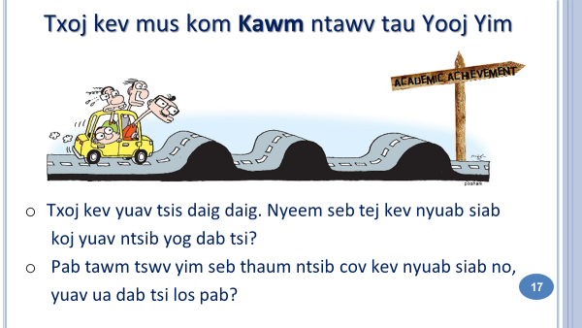  Tauj txoj kev paub ob hom lus yeej tsis nyooj yim. Koj thiab koj tus me nyuam yuav raug kev nyuam siab thiab muaj kev txhawj. Nyob rau hmo no thiab lwm lub lim tiam yog peb yuav tuaj kawm thiab sib txhawb cov teeb meem no ua ke.
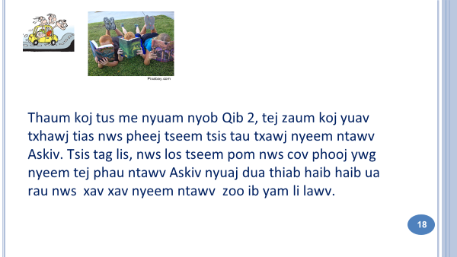 |  | 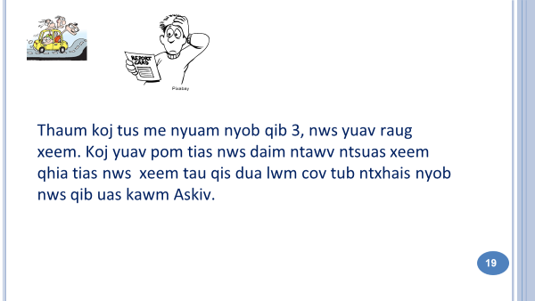
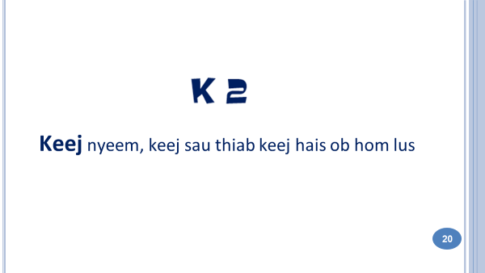  Lub hom phiaj thib ob ntawm kev kawm ob hom lus yog kev keej nyeem, keej sau thiab keej hais ob hom lus. Vim yuav muaj ntau yam peb yuav qhia txog lub hom phiaj no, peb yuav siv txoj kev qhia tom ntej no txog qhov no xwb. Yog li, rov tuaj kawm vim tias qhov no tseem ceeb heev. |  | 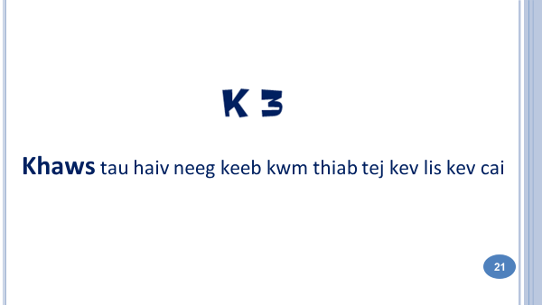
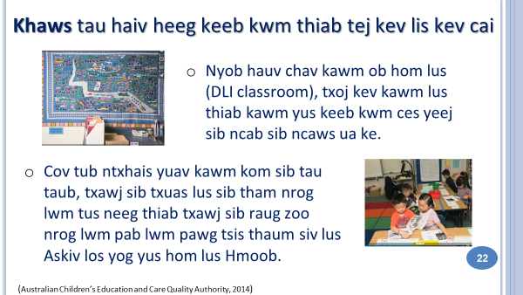 |  | 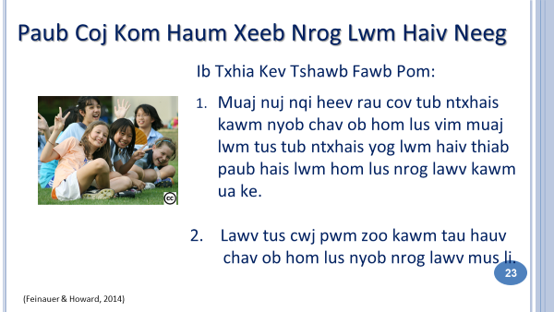
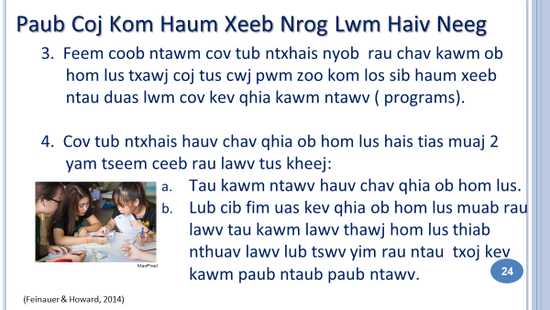 |  | 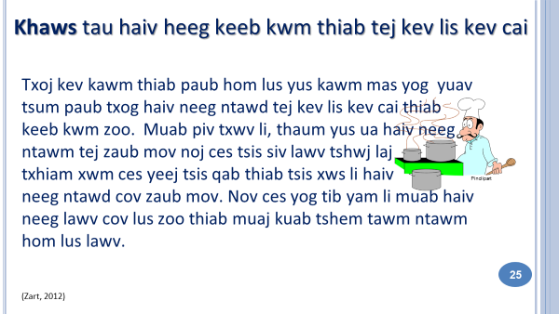
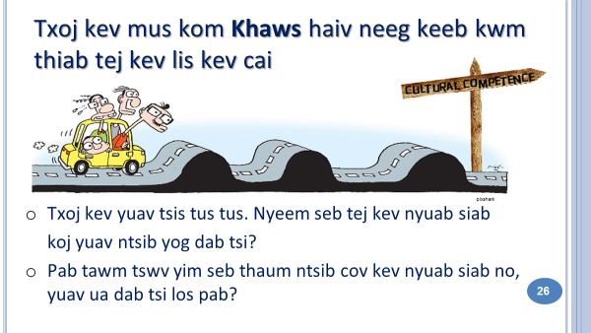 |  | 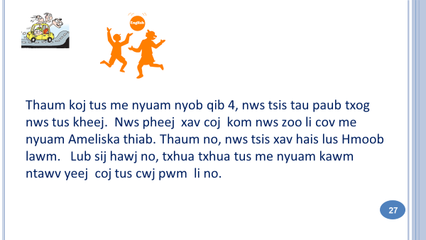  Slide 28: Caij so! Slide 29: DLI BINGO
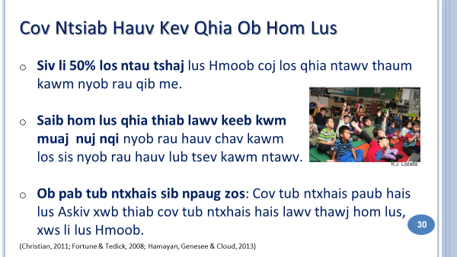 |  | 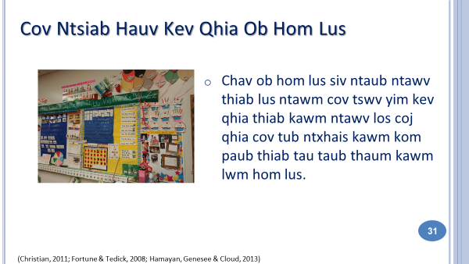  Nov yog ib cov qauv nyob hauv chav kindergarteen daim ntawv qhia txog hnub uas lawv kawm Hmoob. Tus txheej txheem kawm niaj hnub txog leb, Cov tub ntxhais kawm ob hom lus kawm txog cov xim, cov zauv, cov hnub, cov huab cua thiab cov khaub ncaw.
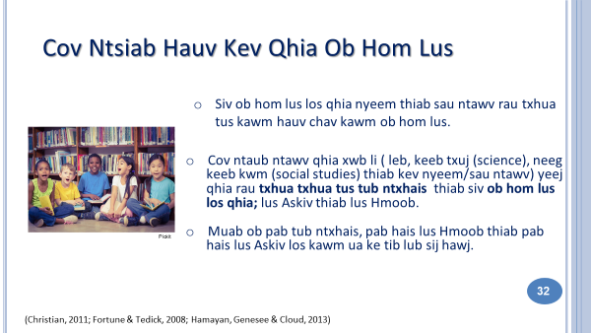 |  | 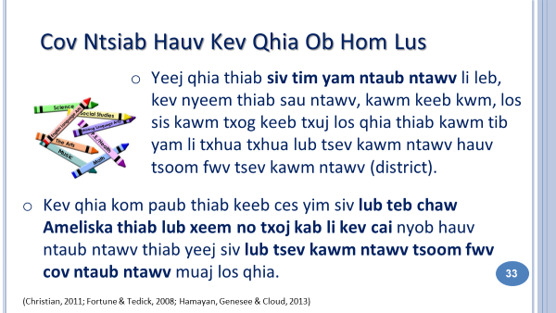
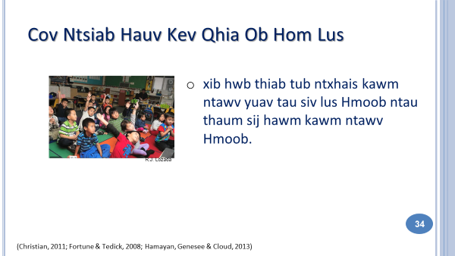 |  | Kev tshawb fawb hais txog ntawm kev kawm ob hom lus pom tau tias thaum qhia ntawv, peb yuav tau siv lus Hmoob kom xwm yeem txhob hloov mus hloov los thiaj kawm tau. Peb yuav tau muab qhov kev qhia ntawv Hmoob saib hlob, xyuas kom rau nqis, thiab nrog tiv thaiv kom zoo. Cov tub ntxhais kawm ntawv YEEJ yuav tsum txawj lus Askiv xwb xwb—Qhov tsis yooj yim yog tsim kom tau cov ntaub ntawv Hmoob los qhia nyob rau hauv tsev kawm ntawv. Tsis yooj yim tib yam nkaus rau cov tub ntxhais hais Hmoob lus.
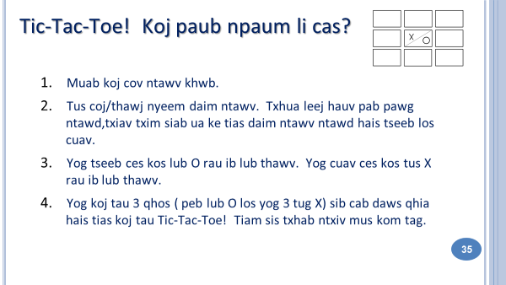  Slides 36 – 37: Tic-Tac-Toe |  | 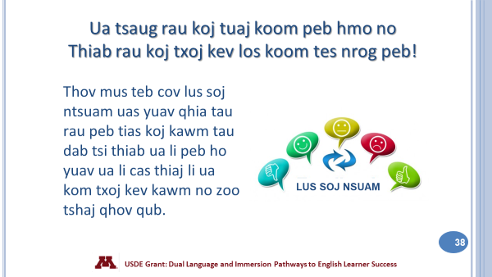
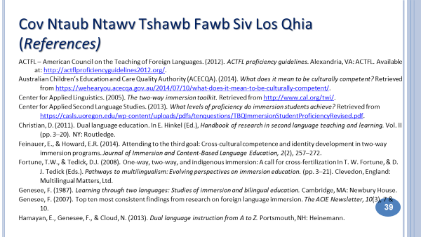 |  | 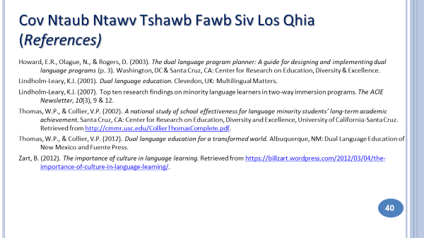
LUS TEB
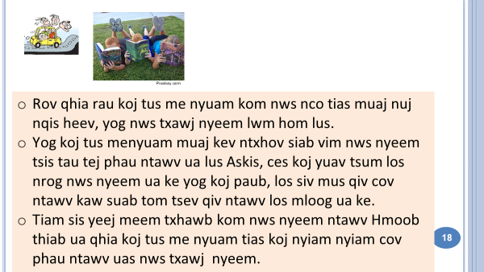 | 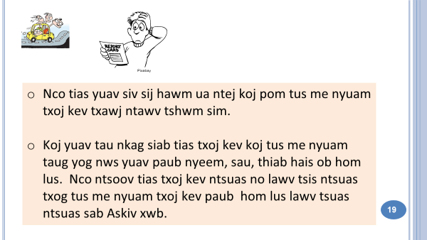
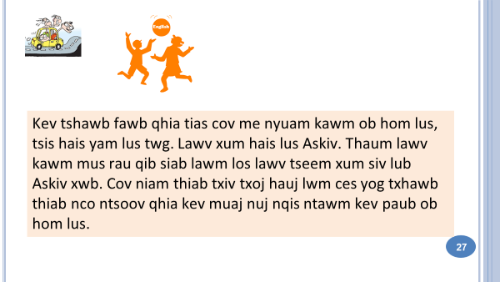 | 