SESSION IV: COLLEGE AND CAREER OPPORTUNITIES
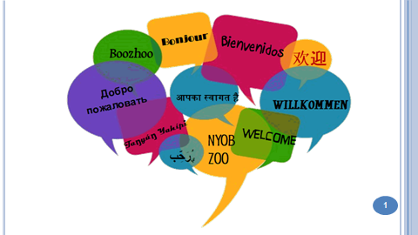 | 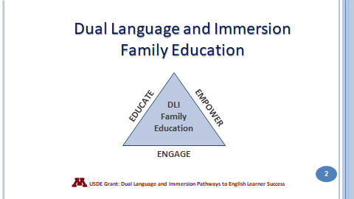
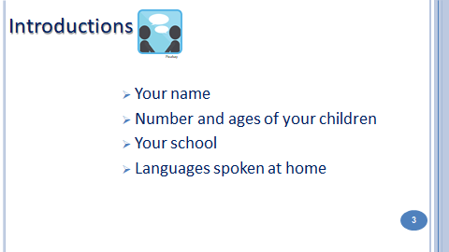 | 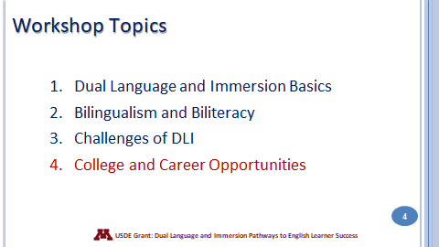
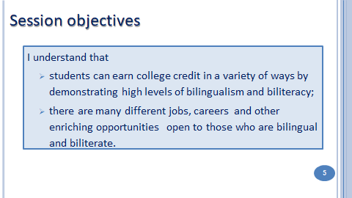 | 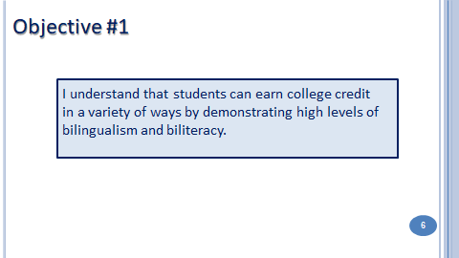
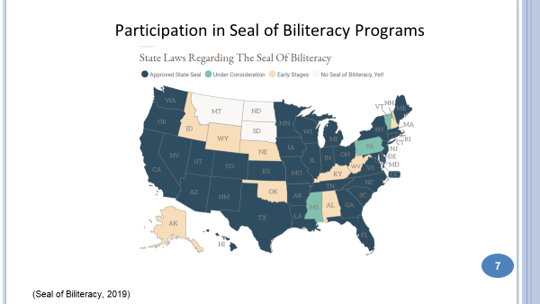  The first Seal of Biliteracy was created in 2008 as part of a grassroots effort by the nonprofit group, “Californians Together.” Their goal was to recognize high school graduates who had obtained high levels of competency in one or more languages in addition to English. The seal has gained in popularity throughout the United States in recent years. | 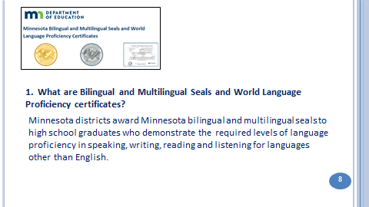

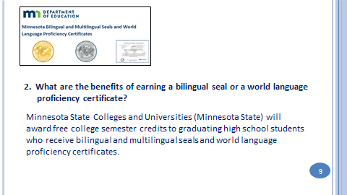 | 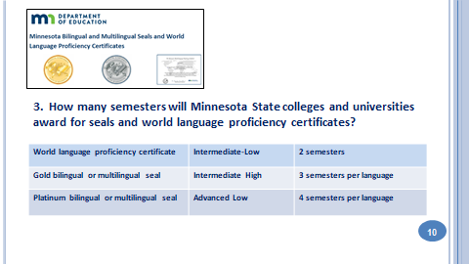
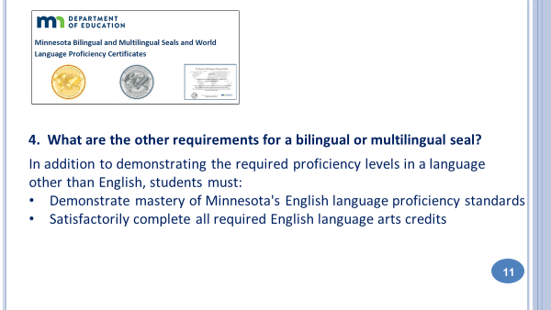 | 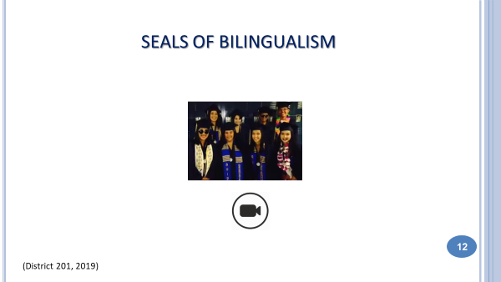
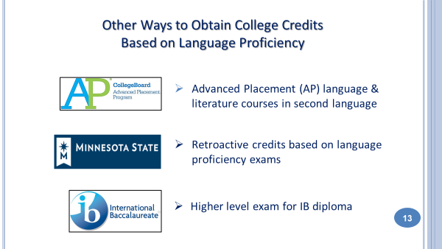
Students with high levels of bilingualism and biliteracy can earn college credits even before going to college through several different paths. These are great ways to earn college credit for FREE!
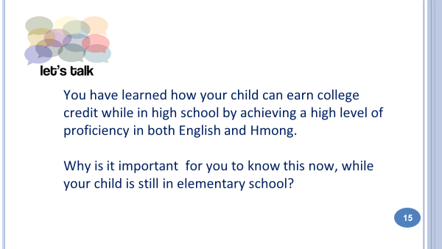 | 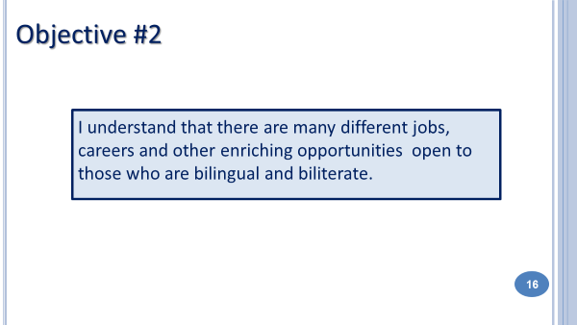
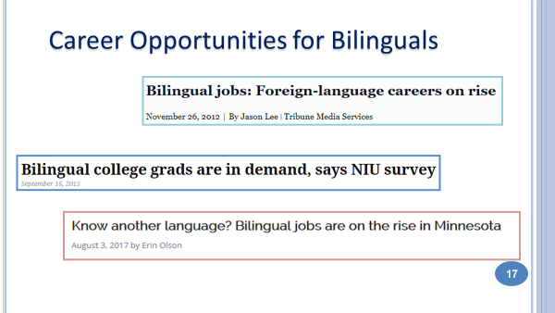 Bilingual speakers are in demand right now and will be even more so in the future. Here are just a few headlines from various news outlets. What can your child expect from a bilingual career? | 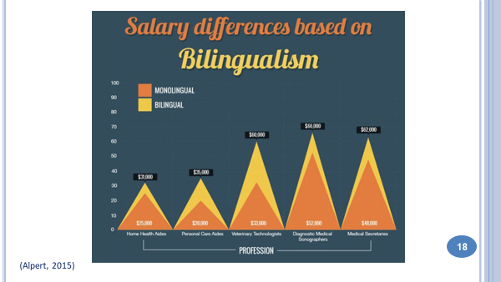  Very often, bilingual speakers earn more money than monolinguals. Here is an example of salary differences in the health care field based on bilingualism.
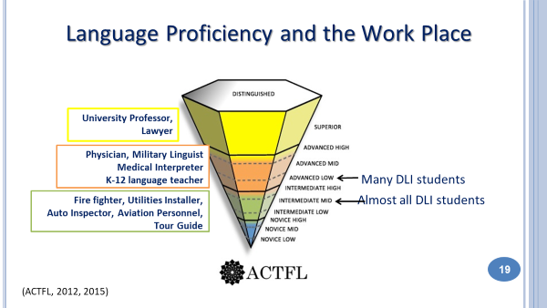 | Enrolling your child in a DLI program is not enough to ensure the level of proficiency necessary for the most demanding careers. such as physician or lawyer. However, you are setting your child on a solid path to a bilingual future. Almost all DLI students who remain in the program from kindergarten through grade 12 achieve proficiency in the Intermediate Mid range. At this level, students are well able hold everyday conversations with native speakers. Many immersion students even reach the Advanced Low range by the end of grade 12.  This graph shows some traditional careers for today’s bilinguals. There will be many other careers for bilinguals in the future that don’t even exist today.
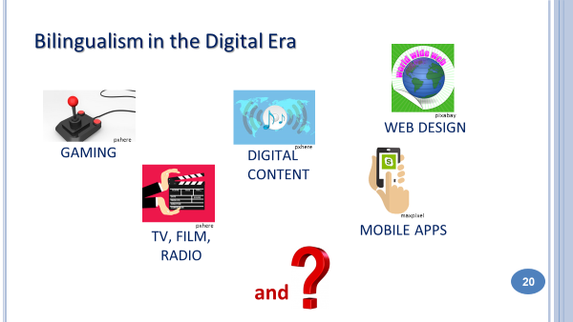Bilinguals have an advantage in the digital economy, which  is global by nature and requires a globally-minded work force. | 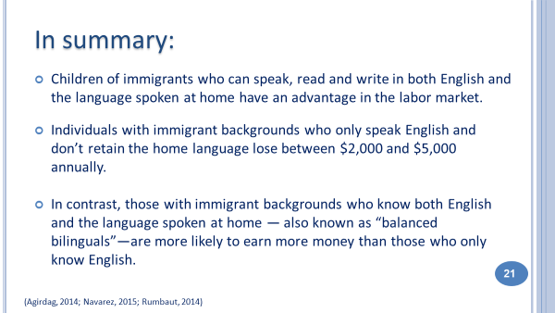
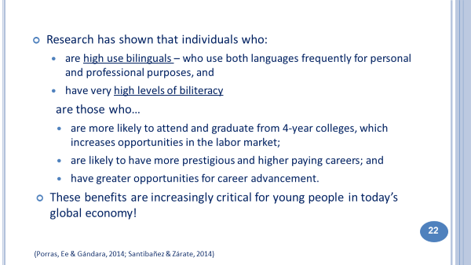 | 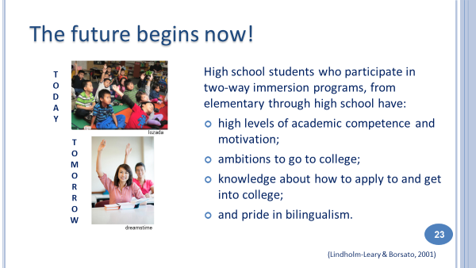
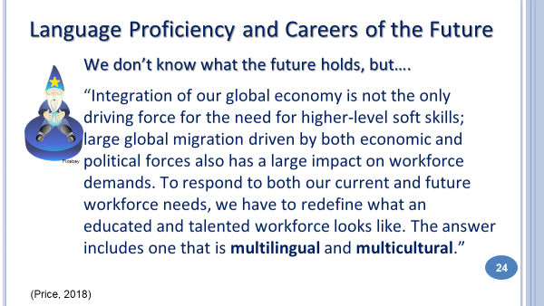  Slide 25: Take a break Slide 26: Let’s Play! | 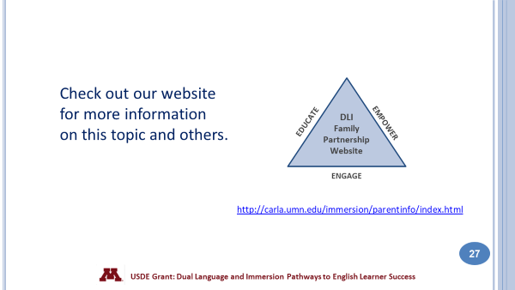
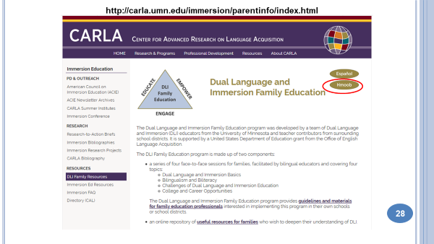 | 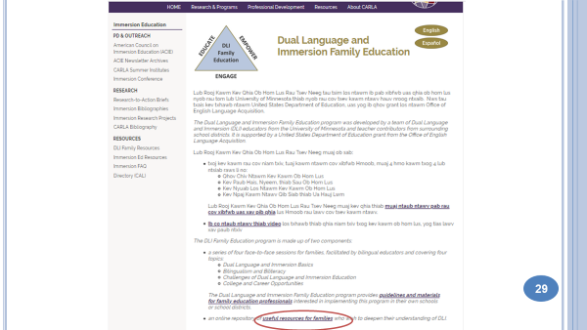
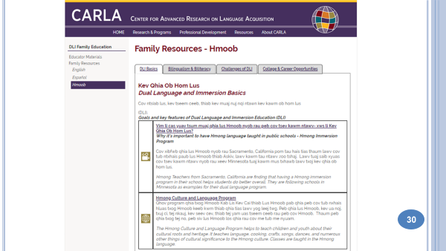 | 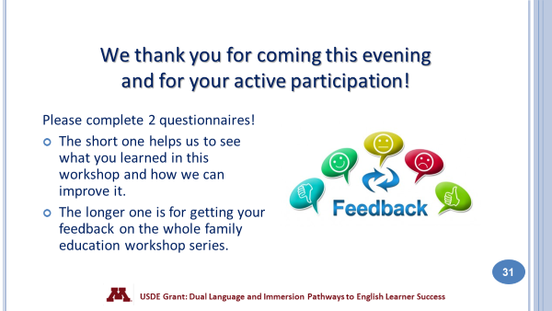
You made it! You’ve completed all four workshops! It’s time to get your certificate and time to celebrate! We are so grateful for your participation and hope that we’ve helped you to understand more about your children’s educational program and how you can help your children to succeed in school and beyond! | 